Part A – Task 1: Postman – OpenWeatherMap API
Objective
The task involved the testing of the OpenWeatherMap REST API using Postman, by making three distinct GET requests, to get weather based on city, get weather based on lat/long coordinates and reverse geocode lat/long coordinates to get the city name.

Step 1 – Weather by City Name
Created an OpenWeatherMap collection.
A GET request named GET Weather by City with the following endpoint was added:
https://api.openweathermap.org/data/2.5/weather?q=Paris&appid=64a07ef3d83c0f6be41d6c385569efe2&units=metric

The following cities were tested:
- Auckland
- Wellington
- Christchurch
- London
- Paris
The following JSON fields were recorded:
- weather[0].description
- main.temp_min
- main.temp_max
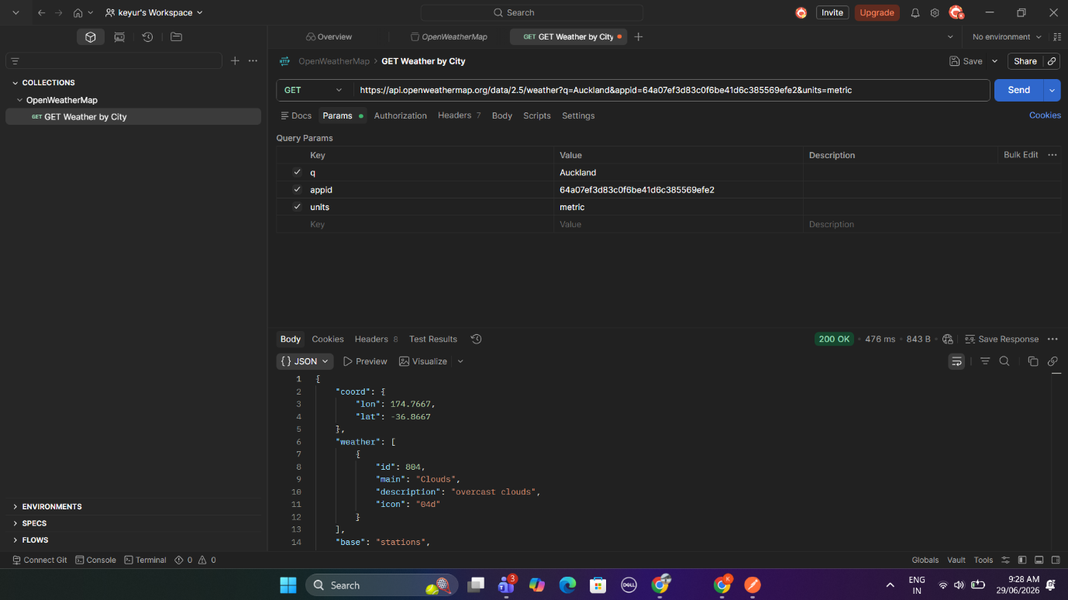
Results
City | Weather Description | Temp Min (°C) | Temp Max (°C)
Auckland | overcast clouds | 11.70 | 13.50
Wellington | overcast clouds | 9.39 | 10.37
Christchurch | broken clouds | 8.30 | 11.62
London | broken clouds | 15.34 | 17.79
Paris | broken clouds | 19.65 | 21.14

Step 2 – Weather by Coordinates
GET Weather by Coordinates Using GET - HTTP - We then created the second GET request called:
https://api.openweathermap.org/data/2.5/weather?q=Paris&appid=64a07ef3d83c0f6be41d6c385569efe2&units=metricT
he following coordinates were tested:
- (40.73, -73.99)
- (45.43, 8.60)
- (-37.81, 144.96)
The following JSON fields were recorded:
- name
- weather[0].description
- main.temp_min
- main.temp_max
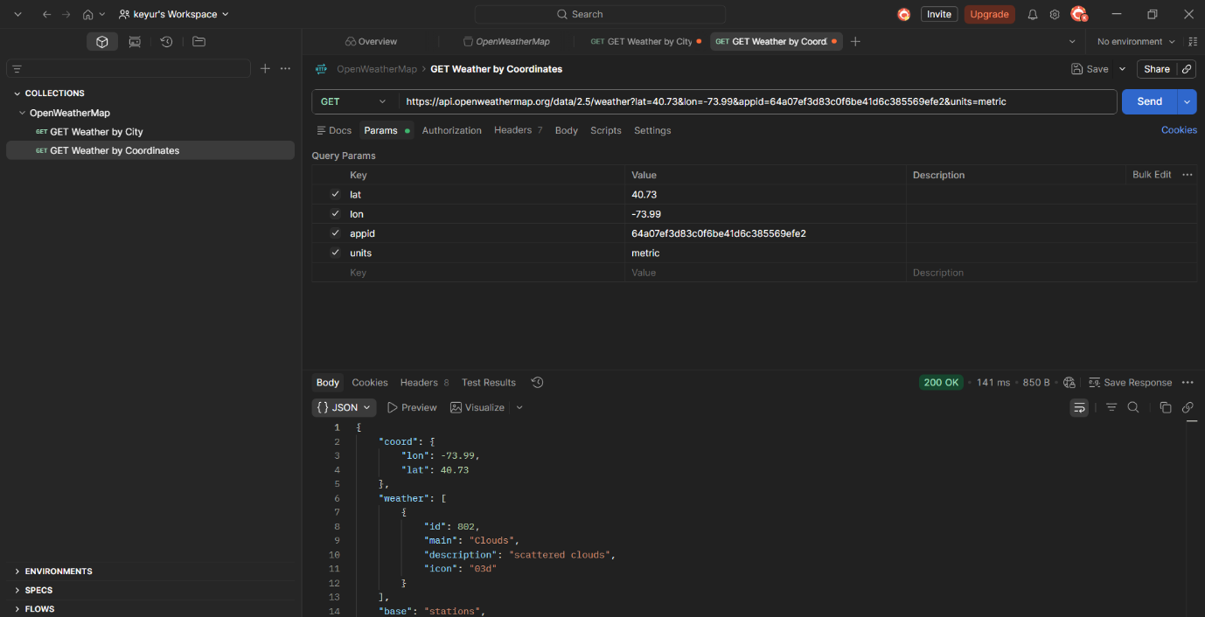
Results
Latitude | Longitude | City Name | Weather Description | Temp Min (°C) | Temp Max (°C)
40.73 | -73.99 | New York | scattered clouds | 23.27 | 26.17
45.43 | 8.60 | Milan | overcast clouds | 25.41 | 25.41
-37.81 | 144.96 | Melbourne | light rain | 12.40 | 13.53

Step 3 – Reverse Geocoding
A new GET request by the name of GET Reverse Geocoding was created by use of this following endpoint:
https://api.openweathermap.org/data/2.5/weather?q=Paris&appid=64a07ef3d83c0f6be41d6c385569efe2&units=metric
The same coordinates were used to identify the corresponding city names.
Results
Latitude | Longitude | City Returned
40.73 | -73.99 | New York
45.43 | 8.60 | Milan
-37.81 | 144.96 | Melbourne

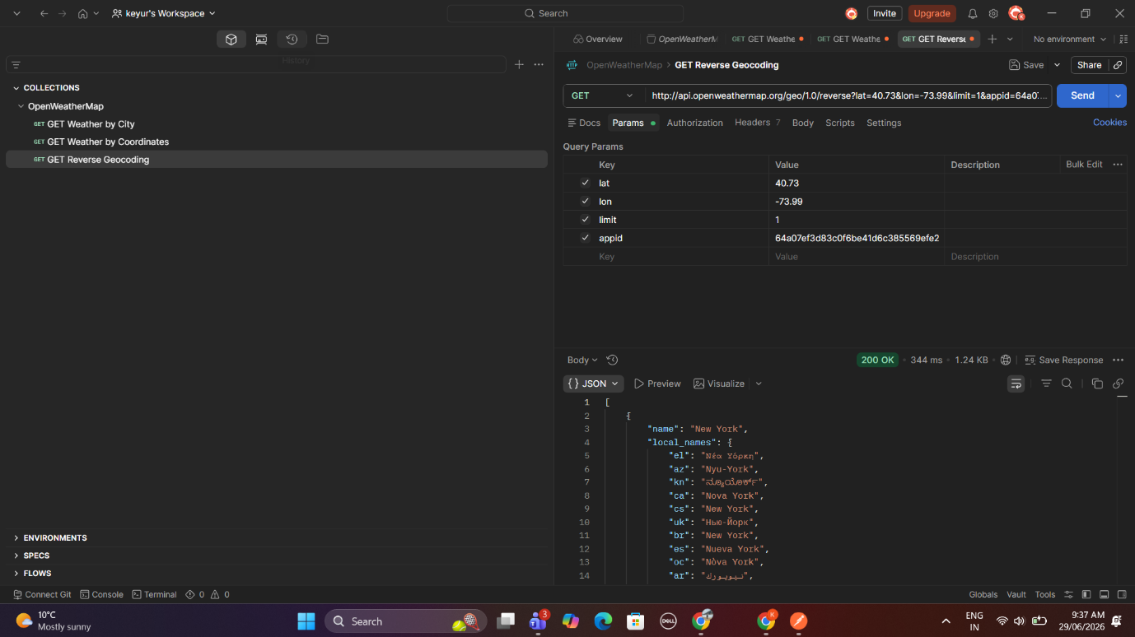.

Conclusion
OpenWeatherMap REST API testing done in Postman. We got weather data by city name and lat/lon coordinates. Reverse geocoding: get city name using latitude and longitude. All requests resulted in successful 200 OK, we successfully got the needed weather info in the responses.
Part A – Task 2: cURL – OpenWeatherMap API
Objective
Weather data was pulled down using the cURL command-line interface and querying the OpenWeatherMap API. Weather information was requested for 3 geographical coordinates and 5 cities through standard HTTP GET requests.

cURL Commands Used
City Weather Example
curl https://api.openweathermap.org/data/2.5/weather?q=Paris&appid=64a07ef3d83c0f6be41d6c385569efe2&units=metric
Coordinates Weather Example
curl https://api.openweathermap.org/data/2.5/weather?q=Paris&appid=64a07ef3d83c0f6be41d6c385569efe2&units=metric

Table 2.1 – Weather by City
City | Weather Description | Temp Min (°C) | Temp Max (°C)
Queenstown | overcast clouds | 12.39 | 12.39
Dunedin | overcast clouds | 7.11 | 7.11
Rotorua | broken clouds | 12.26 | 12.26
Munich | overcast clouds | 18.68 | 20.74
Madrid | few clouds | 19.56 | 21.86

Table 2.2 – Weather by Coordinates
Coordinates | City Name | Weather Description | Temp Min (°C) | Temp Max (°C)
45.43, 8.60 | Novara (Italy) | light rain | 26.13 | 26.13
-33.85, 151.22 | Kirribilli (Australia) | overcast clouds | 12.59 | 14.67
47.60, -122.33 | Seattle (USA) | overcast clouds | 17.30 | 20.07

Conclusion
We were able to retrieve weather data for 5 cities and 3 lat/lon coords by making a cURL request to the OpenWeatherMap API and parsed the weather.description, tempmin and tempmax from the JSON.

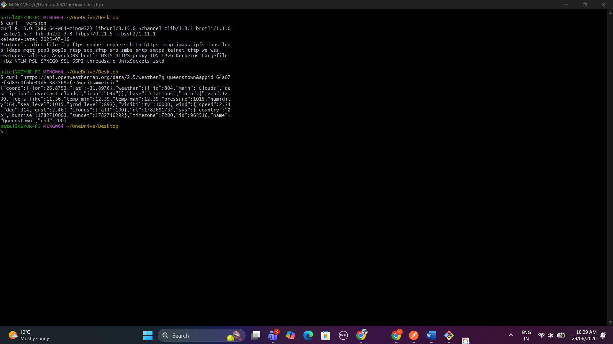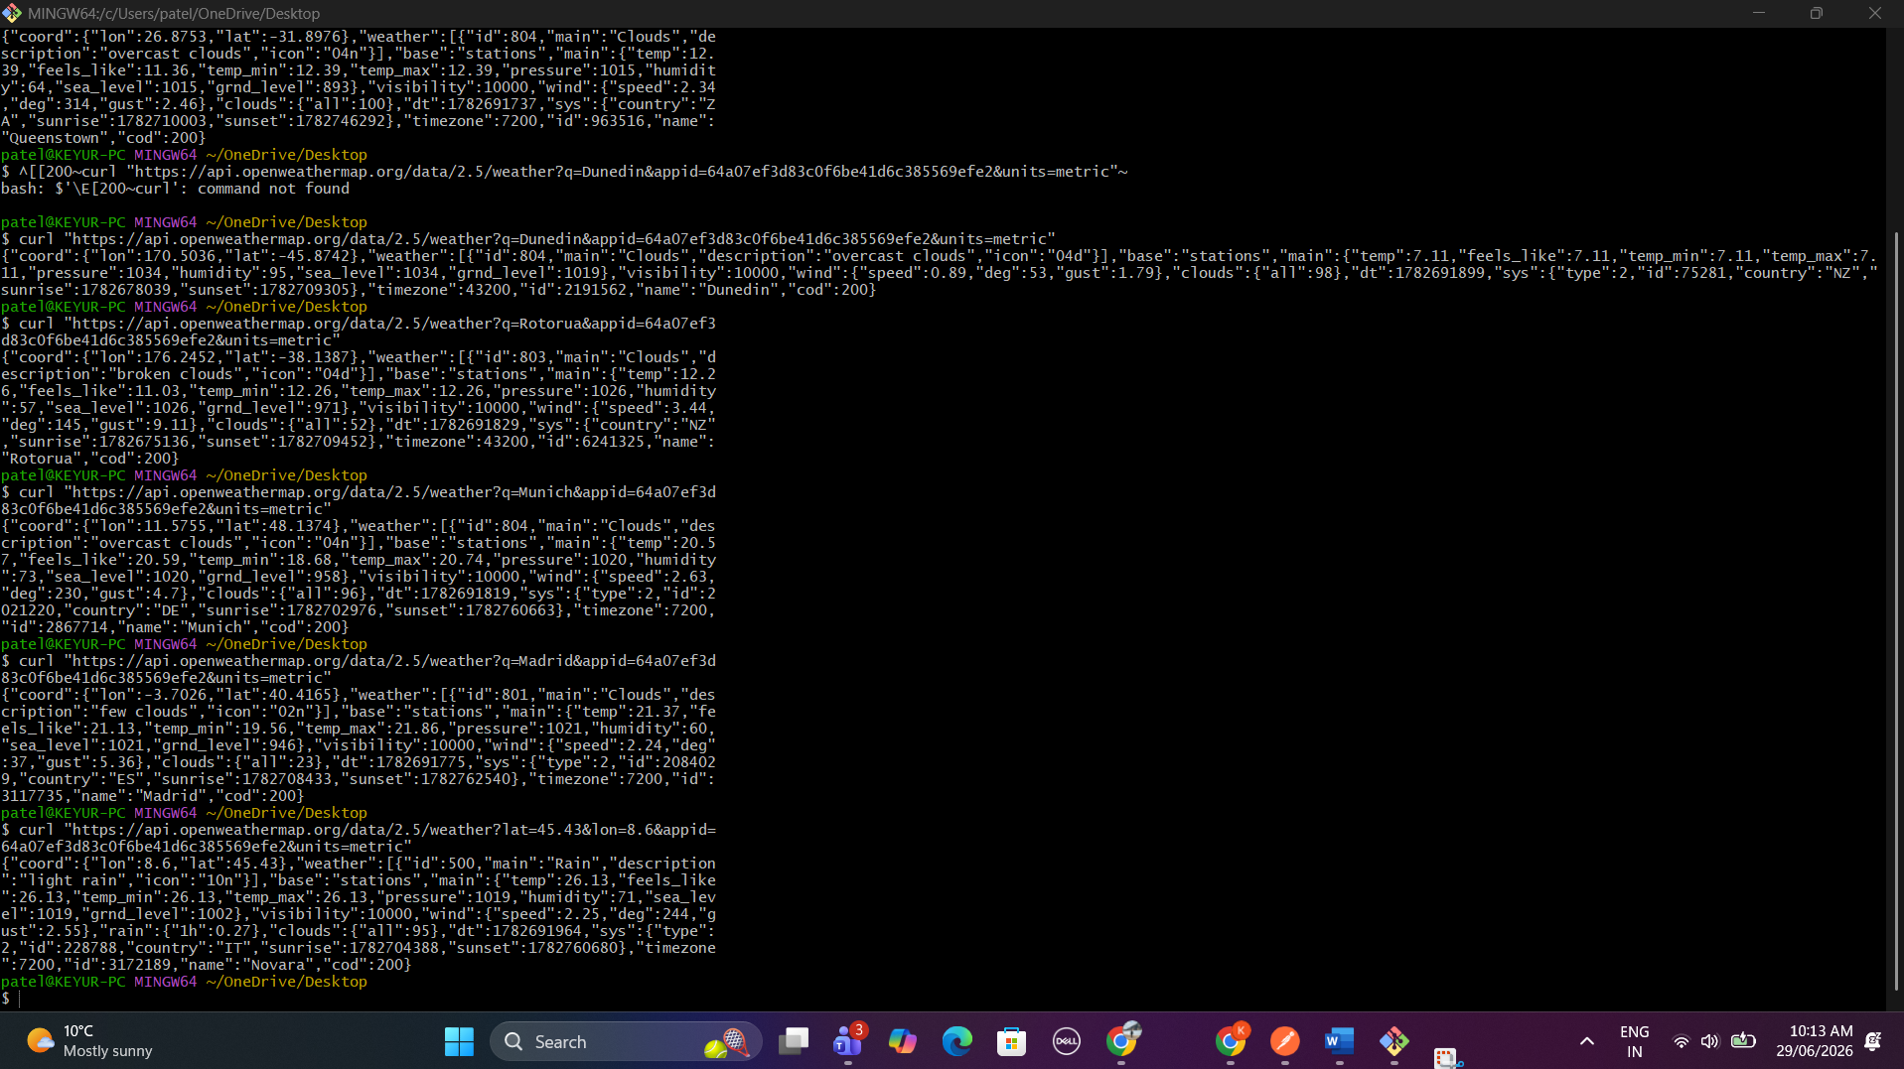
Task 3 – Webhooks with Zapier
Objective
I was tasked with building three automations with Zapier, one for each of my use cases below. For this task, each automation workflow connects two cloud based applications using a trigger and a action that make that workflow happen. The three workflow applications are; Meeting RSVPs, Meeting attendance confirmation emails, and Commit to GitHub.

Zap 1 – Google Forms → Trello (Recording RSVPs)
Description
Team Meeting RSVPs - Google Form was drafted two options of meetings time.
- 10:00 AM – 1 October 2021
- 2:30 PM – 1 October 2021
The form responses were attached to a Google Spreadsheet called Team Meeting RSVPs.

We have set up the Zap below:
Trigger
Google Forms - New Form Response
Action Trello - Create Card
We chose to set the Trello card to appear on the Attendance list on the Team Meetings board, the title to include the name of the attendée along with their chosen session, and their email address to appear on the card's description. It was tested and a new Google Forms submission generated the corresponding card as shown below.

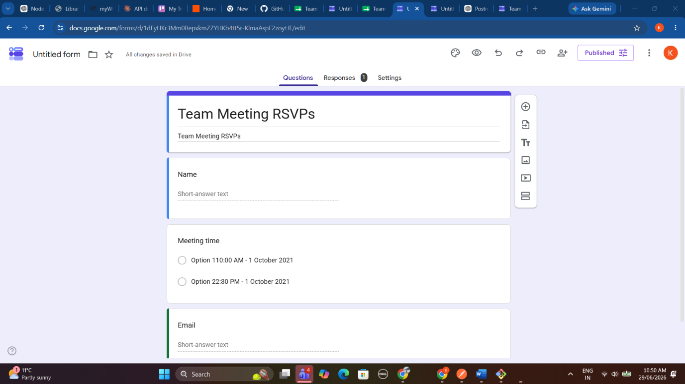
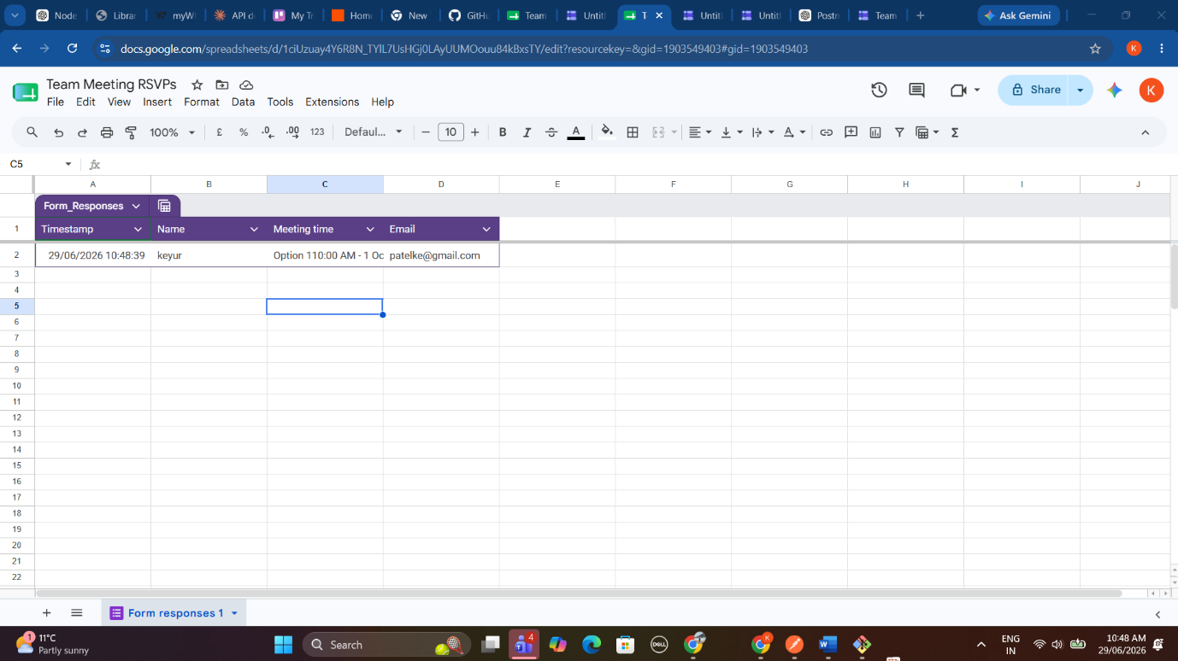
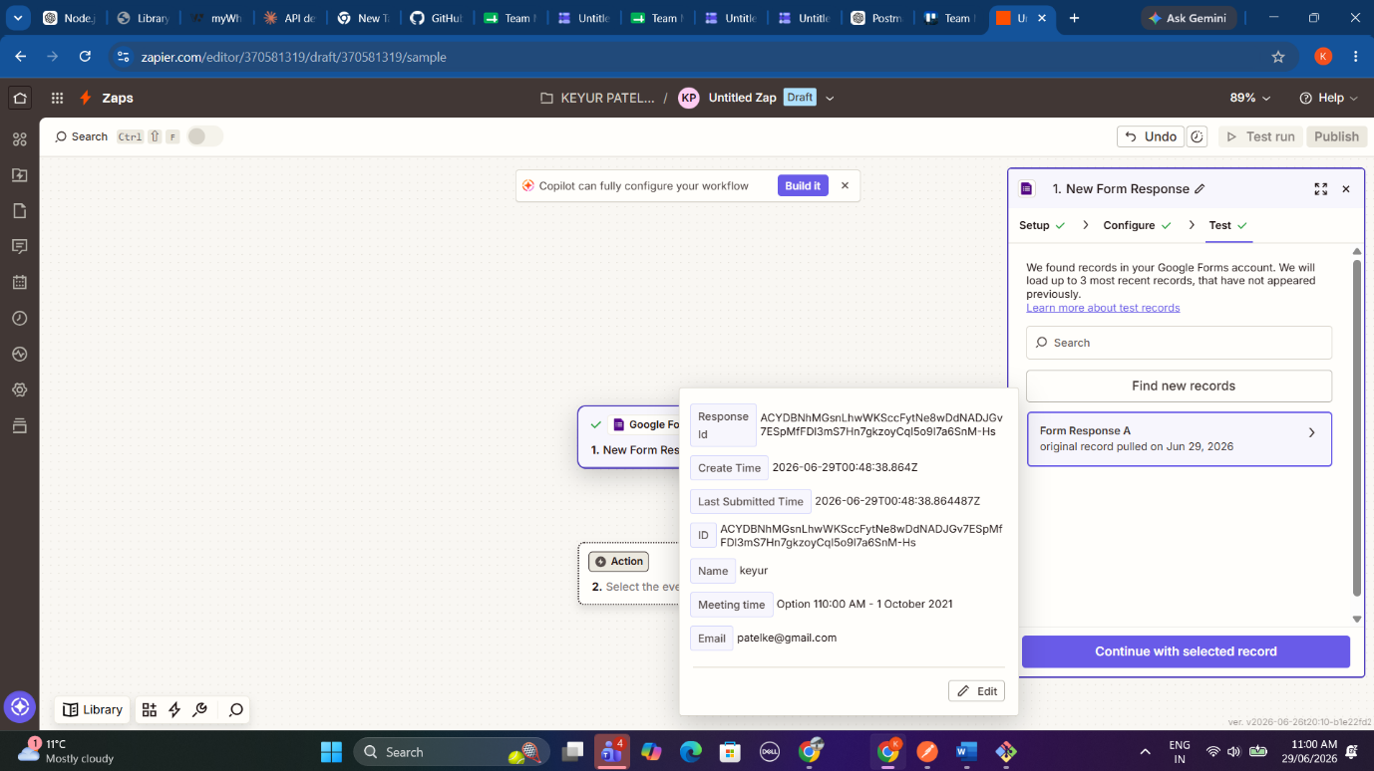
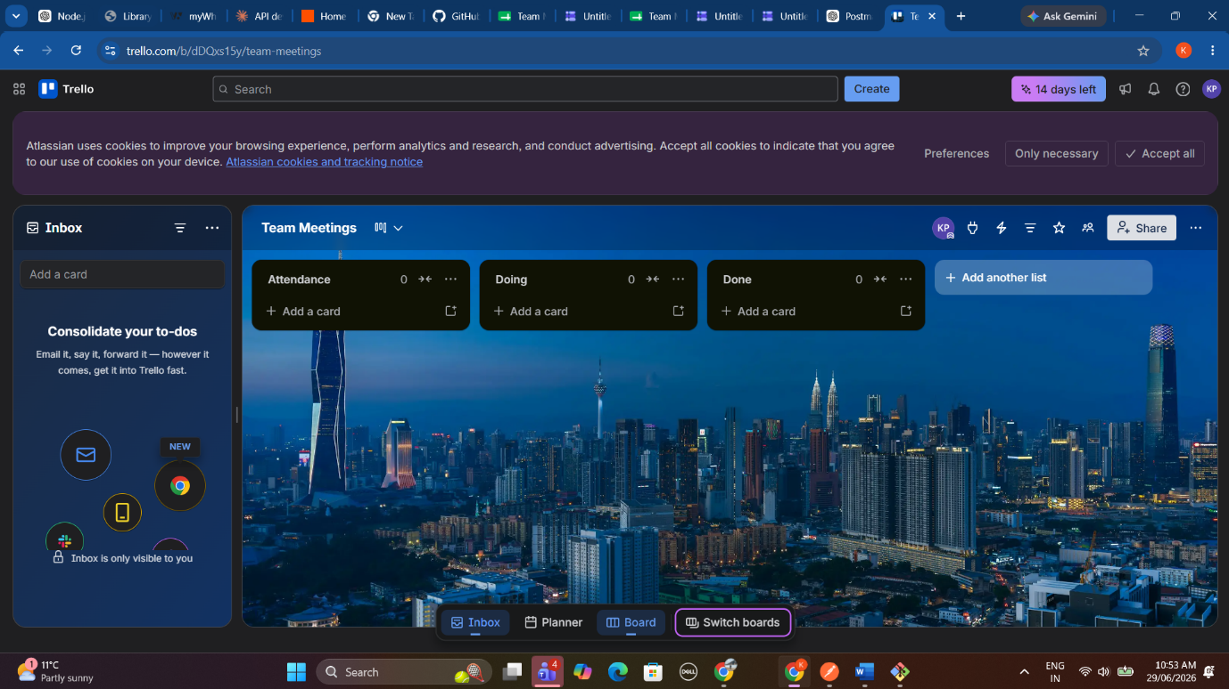
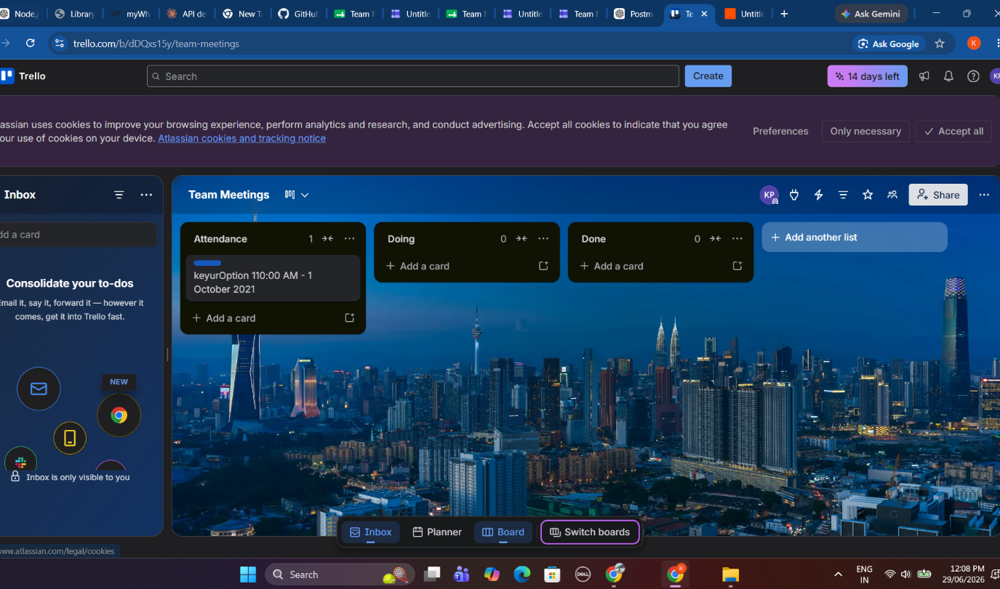
Zap 2 – Trello → Gmail (Email Confirmation)
Description
Secondly, another Zap was set up to create a Gmail draft any time a new card is added to the Trello 'Attendance' list.

Trigger
Trello – New Card
Action
Gmail – Create Draft
The draft email contains:
Subject
Meeting Attendance Confirmation
Body
Attendee name and confirmed attending The zap tested successfully, drafted email was created

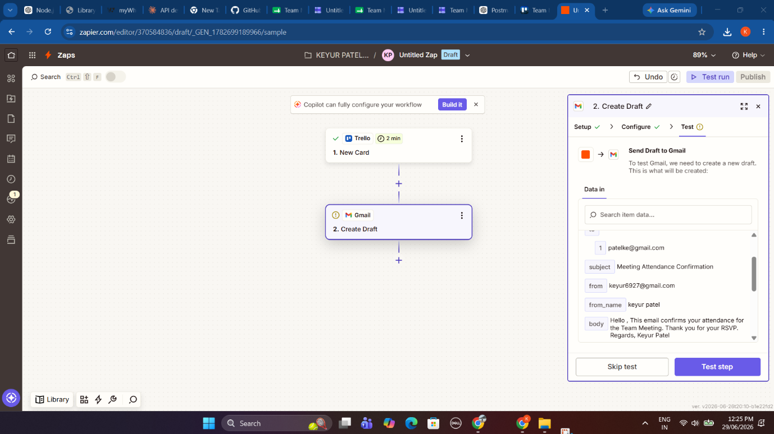
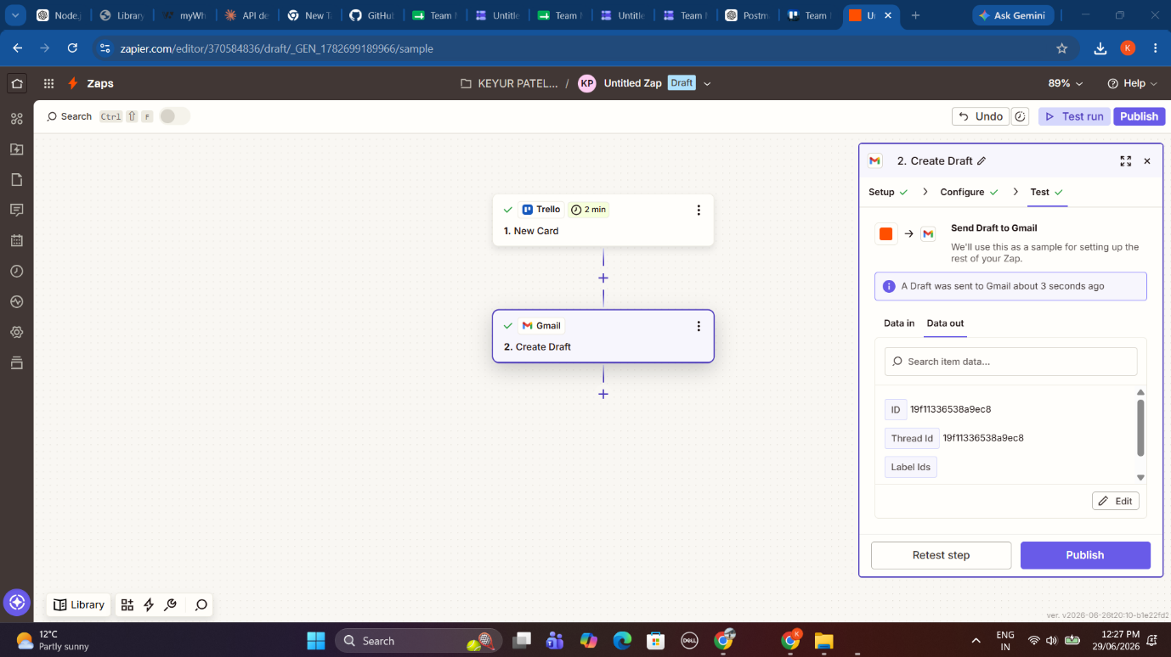
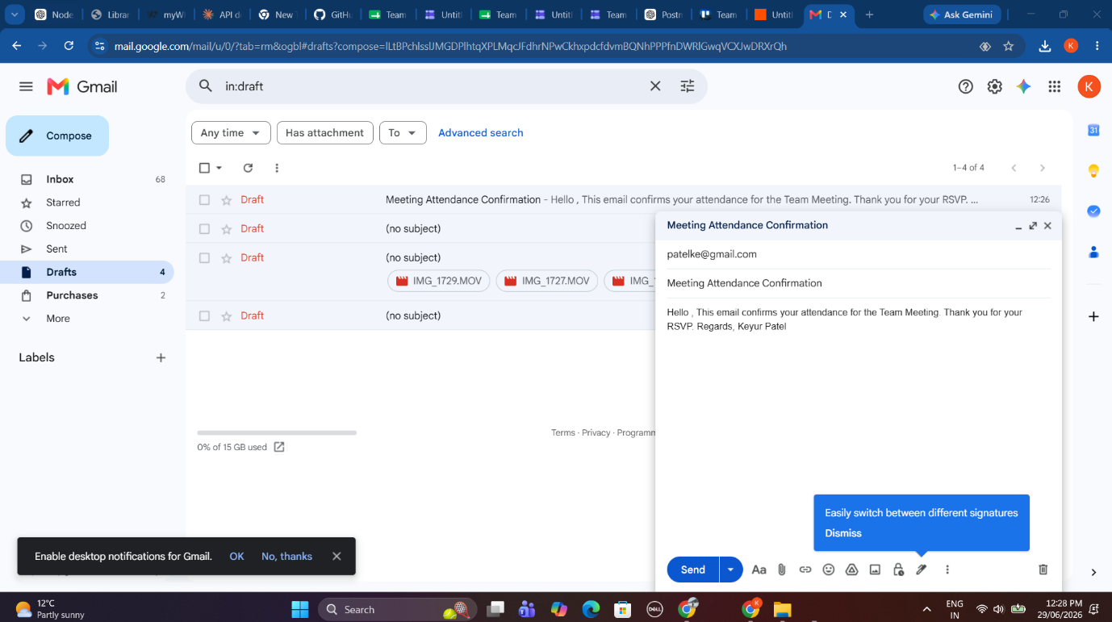
Zap 3 – GitHub → Gmail (Commit Notification)
What was added
attendance-notifier on GitHub
Multiple commits were pushed to the attendance-notifier repository with good commit messages.
A Zap was created using:
Trigger
GitHub – New Commit
Action
Gmail – Send Email
The email contains:
- Commit Message
- Committer Name
- GitHub Commit URL
Tested success by adding another commit to the repository. Received email.

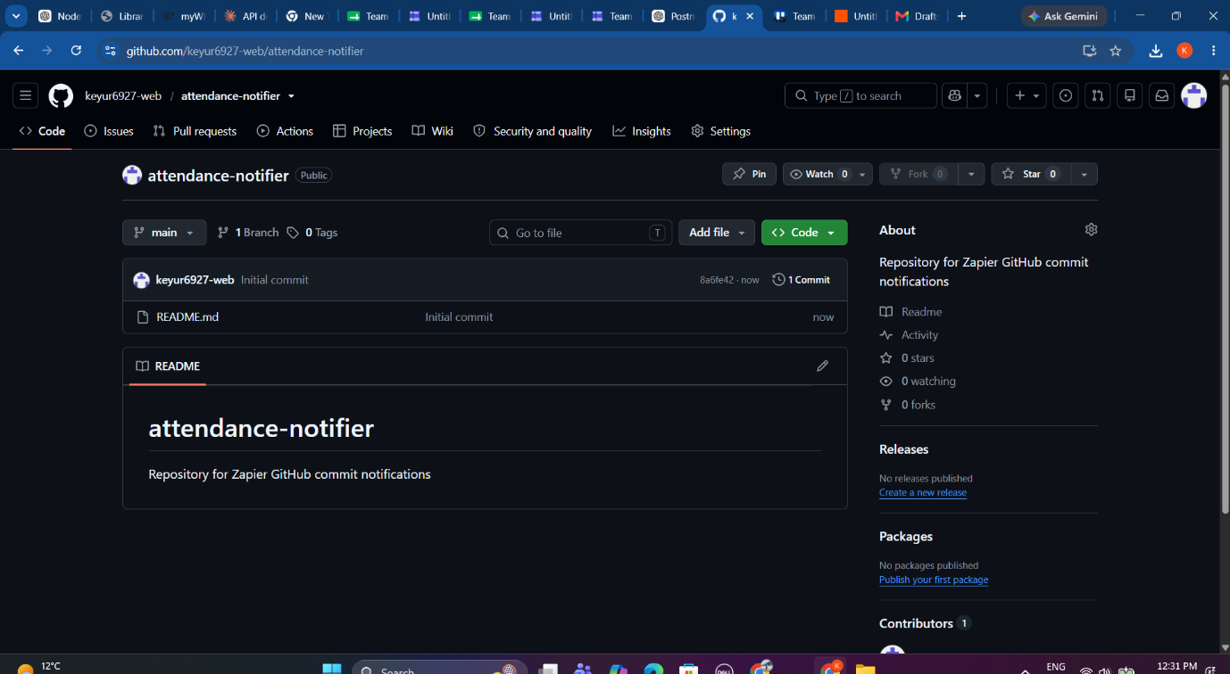
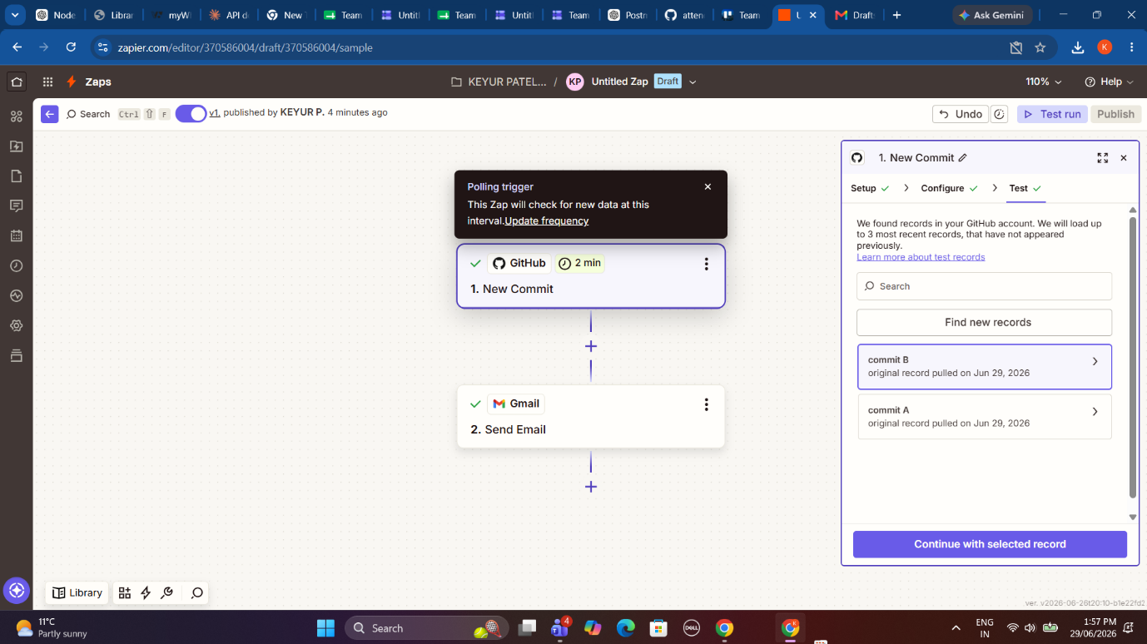
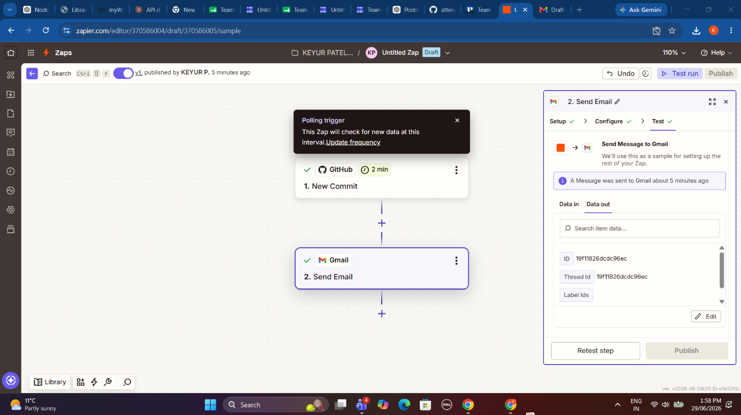
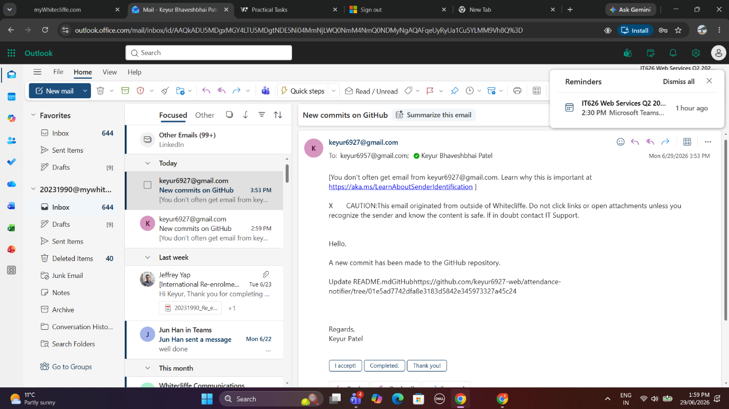
Conclusion
Three automations were created using Zapier and the following three test were executed.
Zap 1 automatically sends the response from Google Form to the create Trello cards.
Zap 2 automatically generates a confirmation Gmail draft for any new added in Trello cards.
Zap 3 automatically send an email when ever a new commit is added to the Github repository.
Task 4 – SOAP API with SoapUI
Objective
This assignment had one requirement; to test SOAP web services in SoapUI. We were to create a new SOAP project in SoapUI using the Online Calculator WSDL. SoapUI generated automatically the request templates for the Calculator’s web services/methods. Then, we had to call the Calculator web services/methods by passing inputs and verify the responses.

WSDL Used
http://www.dneonline.com/calculator.asmx?WSDL

Software Used
- SoapUI 5.10.0
- Online Calculator SOAP Web Service
- Windows 11

Procedure
1.launched SoapUI
2. Created New Project of type Soap
3. Inputted URL of Online Calculator WSDL
4. SoapUI fetched all the Soap operations automatically
5. Opened every request template
6. Filled required input values for the template
7. Executed every soap request
8. Checked the soap response of the service

SOAP Operations
Operation 1 – Add
Input Values
Parameter | Value
intA | 15
intB | 27
Result
15 + 27 = 42
SOAP Response
AddResult = 42

Operation 2 – Subtract
Input Values
Parameter | Value
intA | 50
intB | 18
Result
50 − 18 = 32
SOAP Response
SubtractResult = 32

Operation 3 – Multiply
Input Values
Parameter | Value
intA | 6
intB | 7
Result
6 × 7 = 42
SOAP Response
MultiplyResult = 42

Operation 4 – Divide
Input Values
Parameter | Value
intA | 100
intB | 4
Result
100 ÷ 4 = 25
SOAP Response
DivideResult = 25

Results Summary
Operation | Input Values | Output
Add | 15 + 27 | 42
Subtract | 50 − 18 | 32
Multiply | 6 × 7 | 42
Divide | 100 ÷ 4 | 25

Screenshots
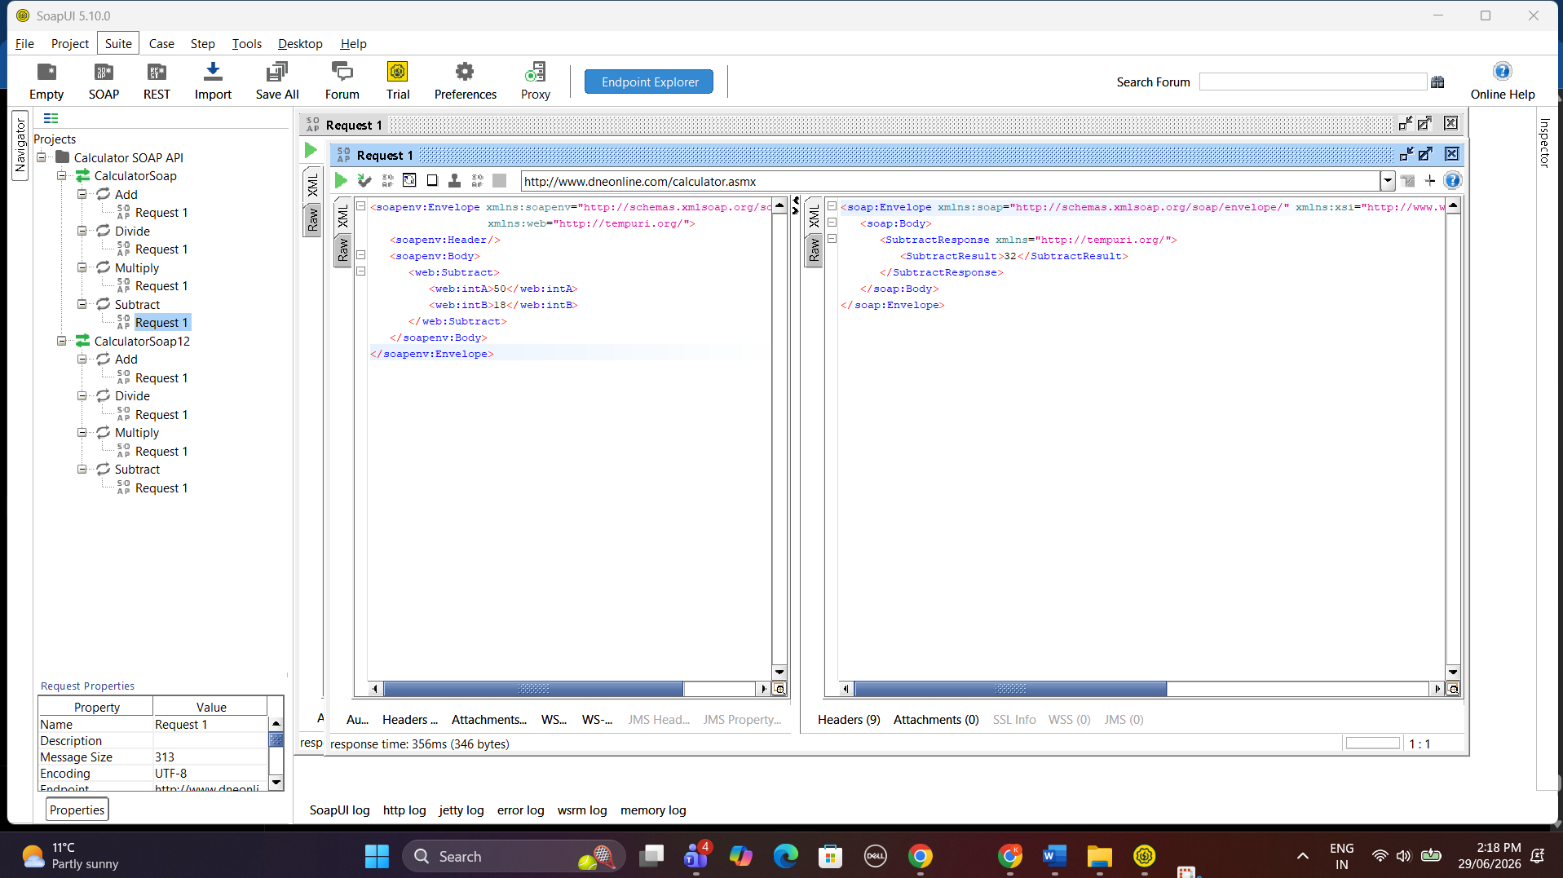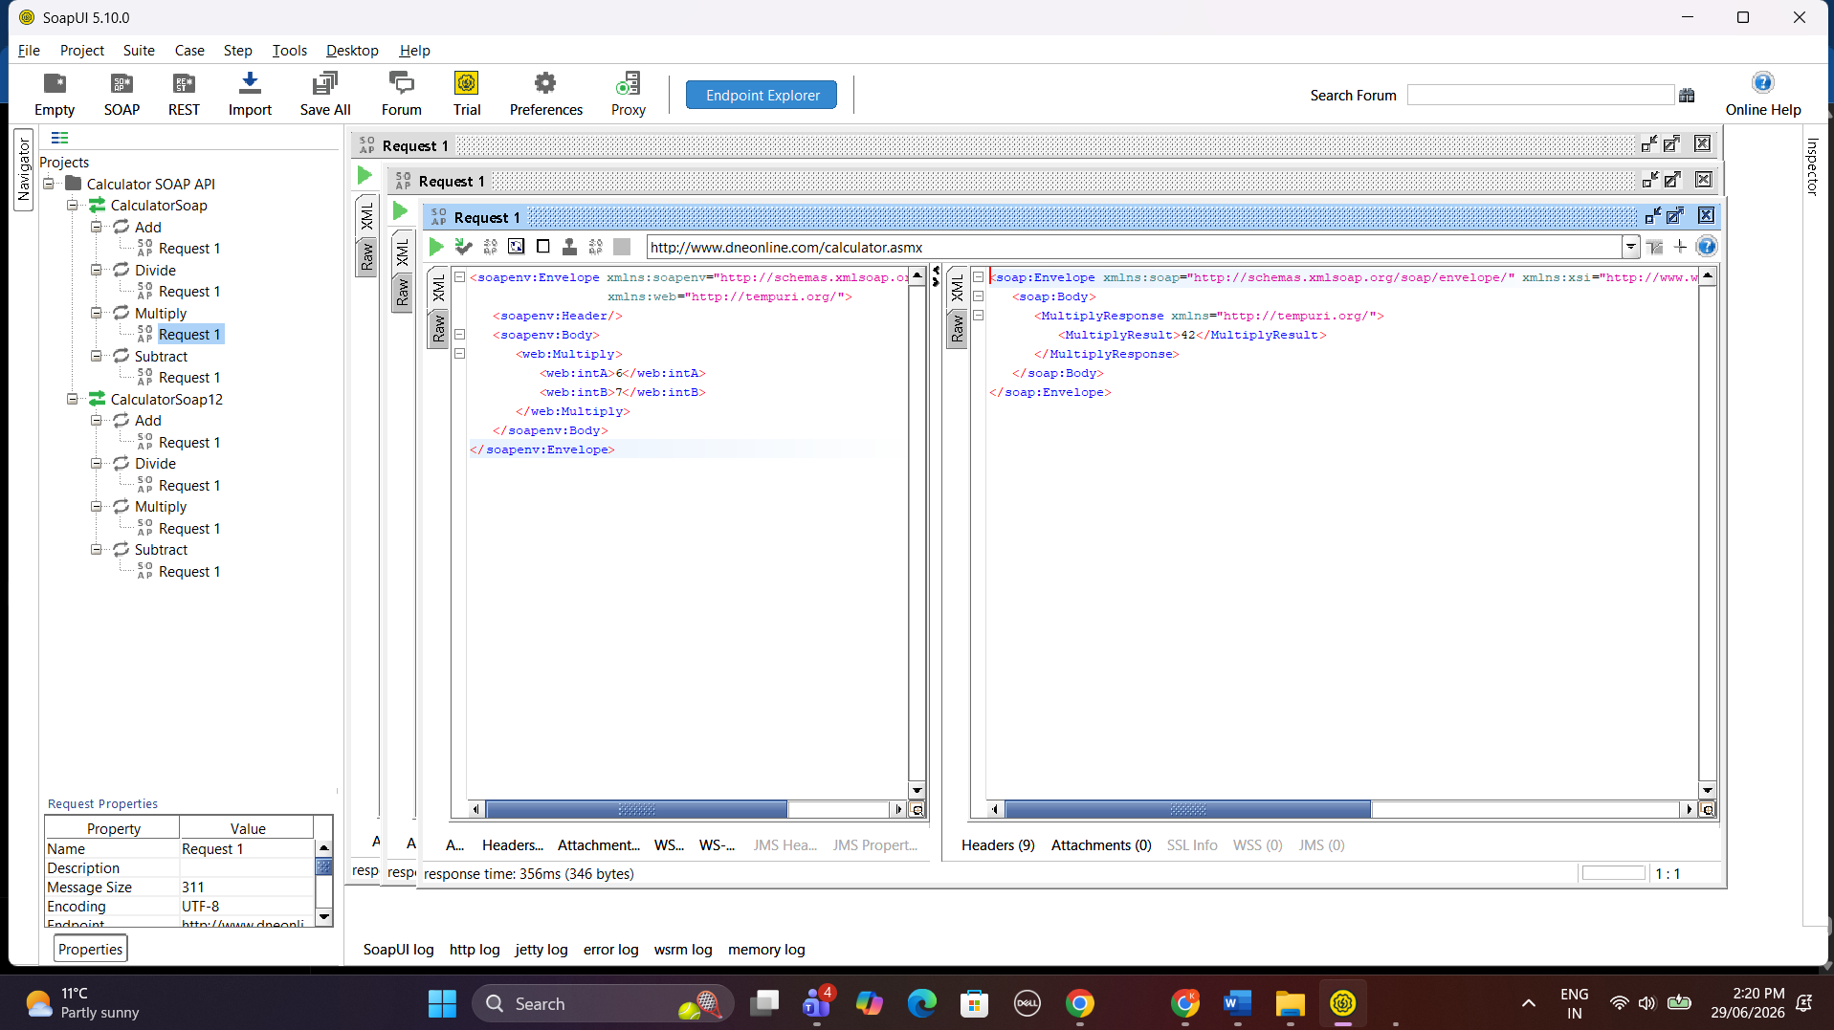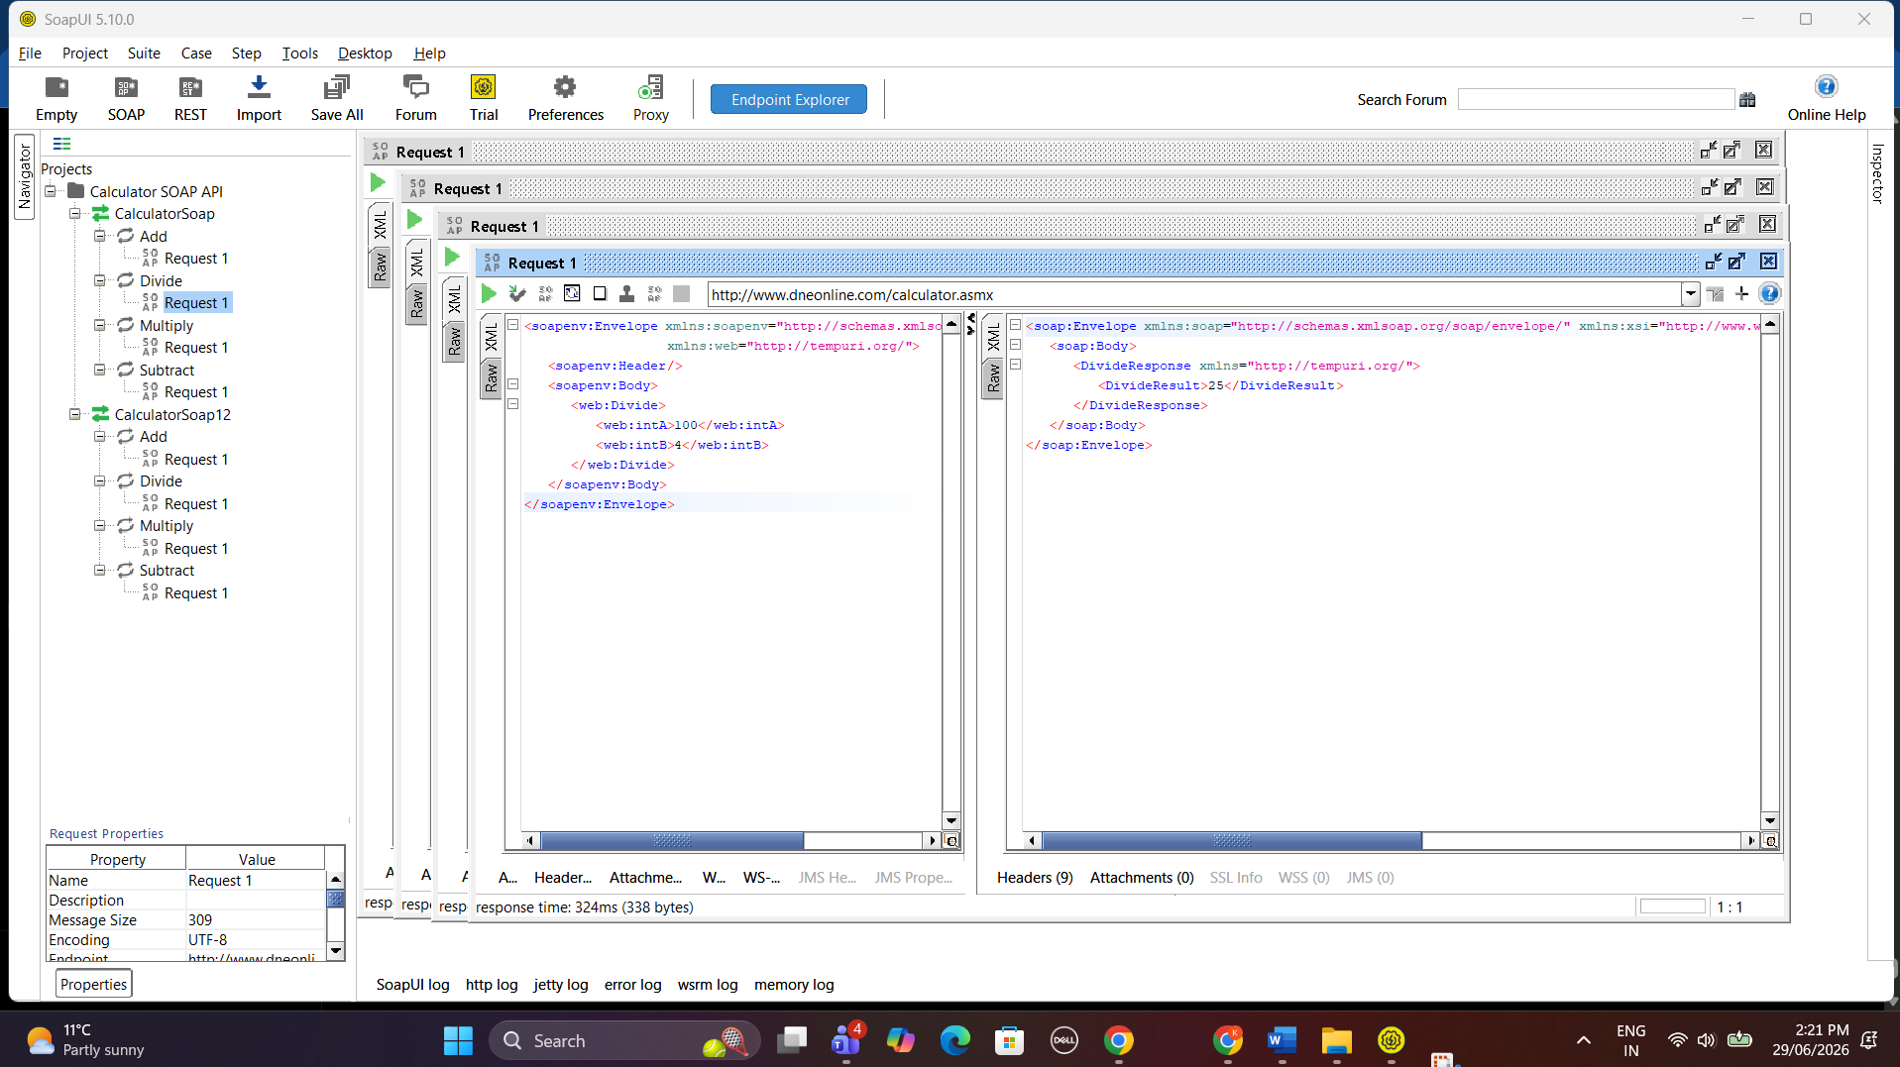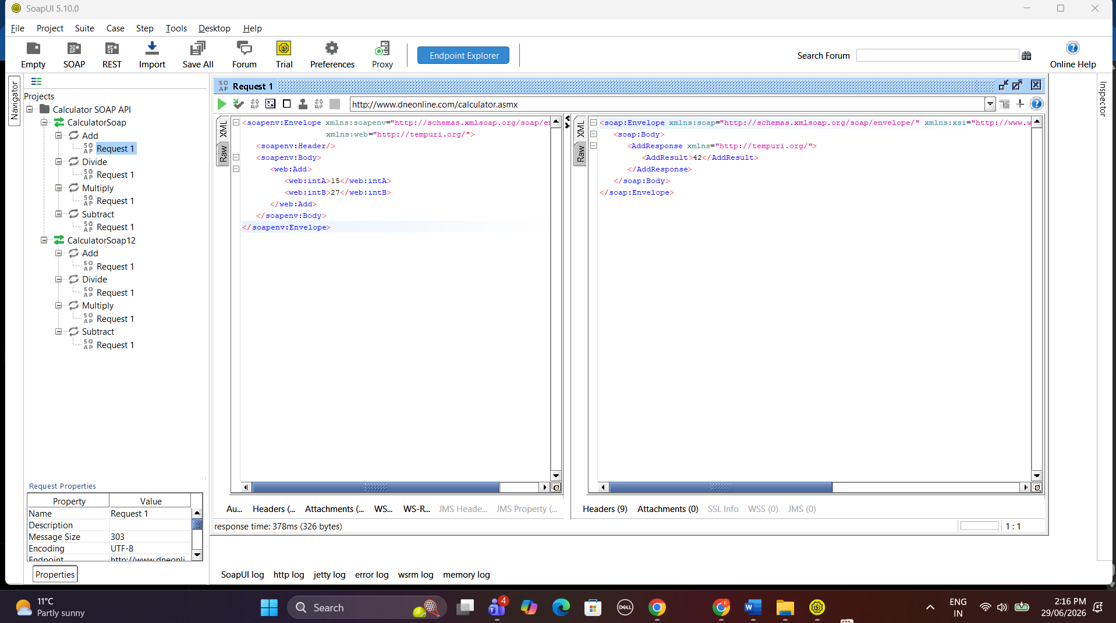
Conclusion
SoapUI was used to test the Online Calculator SOAP web service. All four operations that are exposed by the SOAP web service (Add, Subtract, Multiply and Divide) completed without errors and returned the appropriate responses to the requests that were sent through SOAP. SoapUI successfully handled the processing of the SOAP requests that it was used to make, the responses came back as they were intended to do based on the XML that SoapUI received from the web service.
PART B – Task 1: API Planning – Music Hub
API Planning
Overview
MusicHUB API The Music Hub API is an RESTful Web API that enables the access, alteration and organization of music data that include Artists, Albums and Tracks. It is built to serve the needs of Music streaming services, Applications that need fast and secure access to music.

Who will use the API?
- Music Hub API is suited for:
Fans who enjoy listening to music and are interested in the available songs, albums and artist information.
Music artist who wishes to manage his/hers song, albums and artist related data.
Developers who are building music application and need an efficient interface with data.
Music streaming sites who need music data to provide the service.

Benefits of the API
Some of the great advantages of the Music Hub API include:
You can search artist information, album details and song data programmatically.
You can get the entire Music Catalogue instantly.
You can alter your current music entries.
Remove redundant music entry from the database.
Connect to the Music streaming applications.
Easy to handle music information with the web services using RESTful protocol.

HTTP Requests (API Endpoints)
GET Requests (Retrieve All Records)
HTTP Method | Endpoint | Description
GET | /songs | Retrieve all songs
GET | /albums | Retrieve all albums
GET | /artists | Retrieve all artists

GET Requests (Retrieve One Record)
HTTP Method | Endpoint | Description
GET | /songs/:id | Retrieve a specific song by ID
GET | /albums/:id | Retrieve a specific album by ID
GET | /artists/:id | Retrieve a specific artist by ID

PUT Requests (Update Records)
HTTP Method | Endpoint | Description
PUT | /songs/:id | Update an existing song
PUT | /albums/:id | Update an existing album

DELETE Requests (Delete Records)
HTTP Method | Endpoint | Description
DELETE | /songs/:id | Delete a song
DELETE | /albums/:id | Delete an album

Summary of HTTP Requests
Request Type | Number Required | Number Included
GET (All) | 3 | 3
GET (Single) | 3 | 3
PUT | 2 | 2
DELETE | 2 | 2
Total | 10 | 10

Planned Collections
The Music Hub API will use the following MongoDB collections:
- Artists – Stores artist information including name, genre, and country.
- Albums – Stores album details including title, release year, artist reference, and genre.
- Songs – Stores song information including title, duration, album reference, and artist reference.

Planned Functionality
The Music Hub API will provide the following functionality:
- Retrieve all artists, albums, and songs.
- Retrieve individual artists, albums, and songs by their unique ID.
- Update existing song and album information.
- Delete songs and albums from the database.
- Provide a RESTful interface for integration with music applications.
Task 2: API Design with RAML
Objective
This task involved designing a RESTful API for a Music Hub application using RAML 1.0 specification. The API documentation is generated based on the Week 7 RAML Lab document, replacing the Library API resources by Music Hub resources.

Implementation
A RAML file named api.raml was created in Visual Studio Code. The API includes the following features:
- API title: Music Hub API
- Version: v1
- Base URI: http://localhost:3000/api
- Media Type: application/json
- Basic Authentication security scheme
- User endpoints for signup and login
- Artist endpoints
- Album endpoints
- Song endpoints
- GET, POST, PUT and DELETE operations
I used the raml2html tool to convert the RAML specification to HTML documentation by the command: raml2html -i api.raml -o api.html As shown in the above screenshot, the generated HTML documentation contains all the API endpoints along with the list of HTTP methods supported by the same.

Screenshots
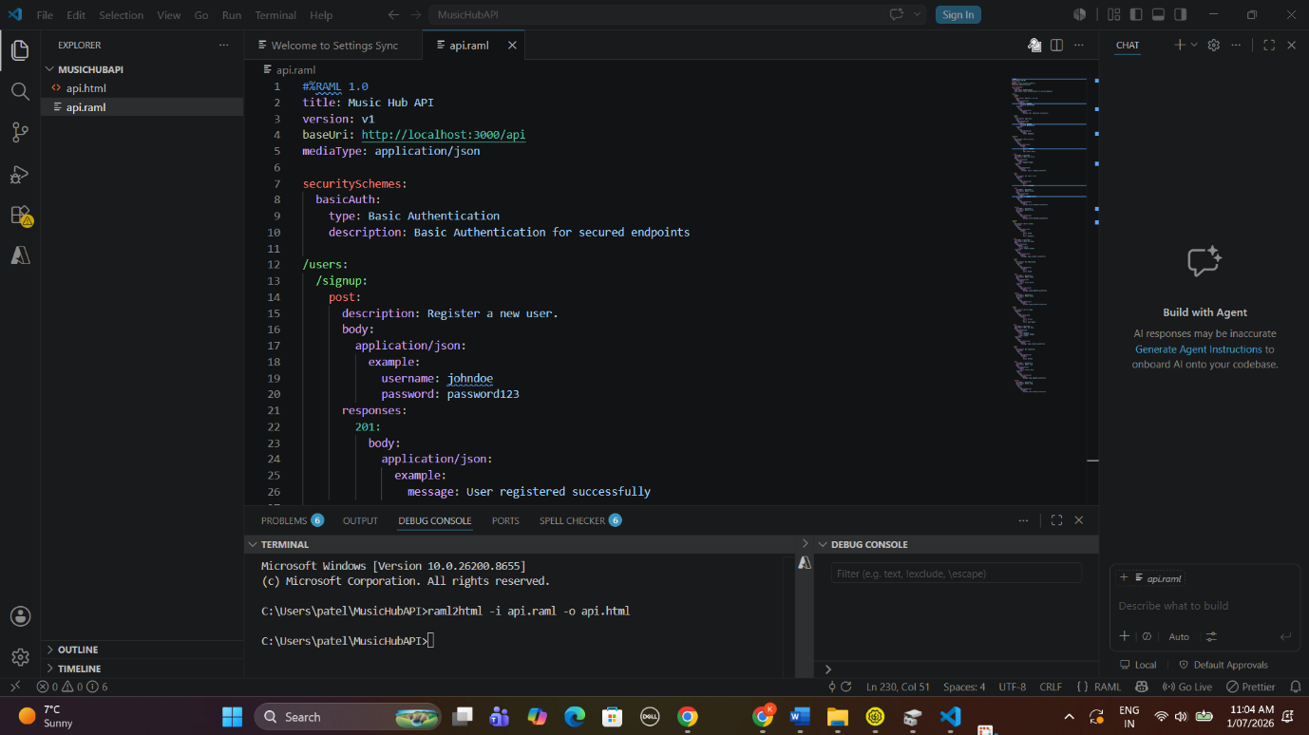
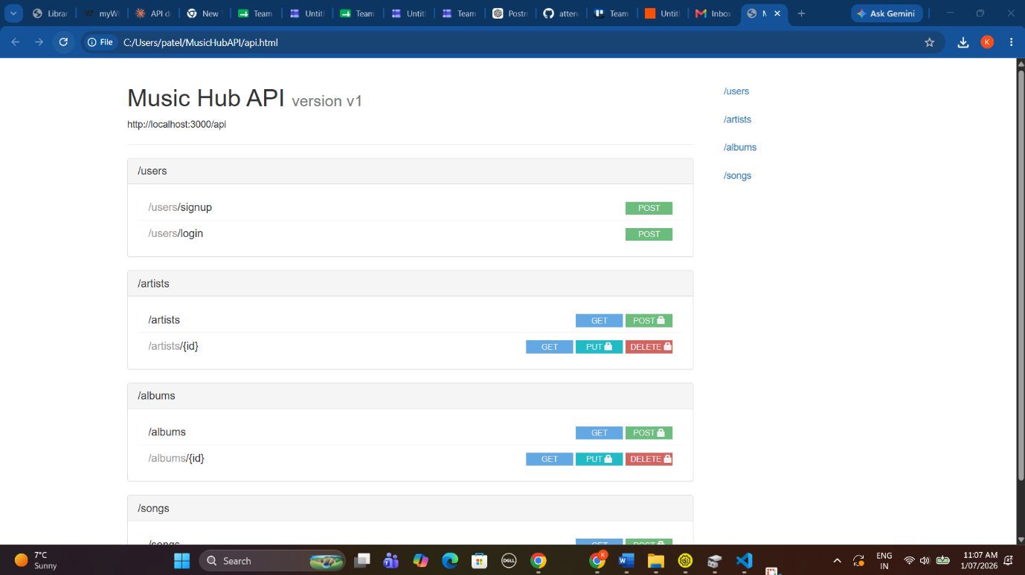
Result
Music Hub API have been design using RAML. API documentation has been created successfully as HTML. And it show all resources , endpoints, http methods , security configuration.
Task 3 – MusicHub REST API using Node.js, Express and MongoDB
Objective
MusicHub A RESTful API that manages a Music Catalog with complete CRUD (Create, Read, Update and Delete) functionality for Artists, Albums and Songs following the MVC design pattern. It is built with Node.js, Express.js, and MongoDB.

Development Environment
- Visual Studio Code
- Node.js
- Express.js
- MongoDB
- MongoDB Compass
- Postman
- Mongoose ODM

Project Structure
The project follows the MVC (Model-View-Controller) architecture.
Folders included:
- controllers
- models
- routes
- middleware
- server.js
- package.json
- .env
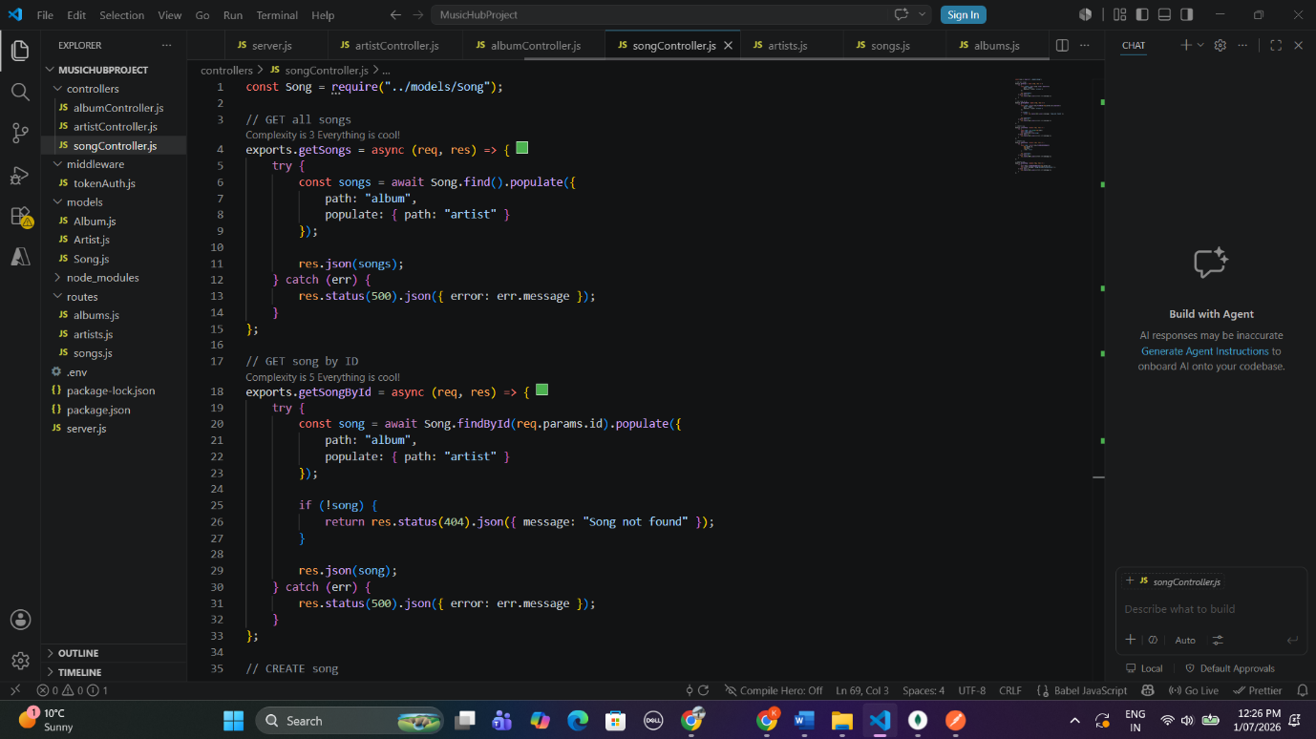
Server Connection
The Express server was successfully connected to MongoDB and started on port 3000.
Output:
Server running on port 3000
MongoDB Connected
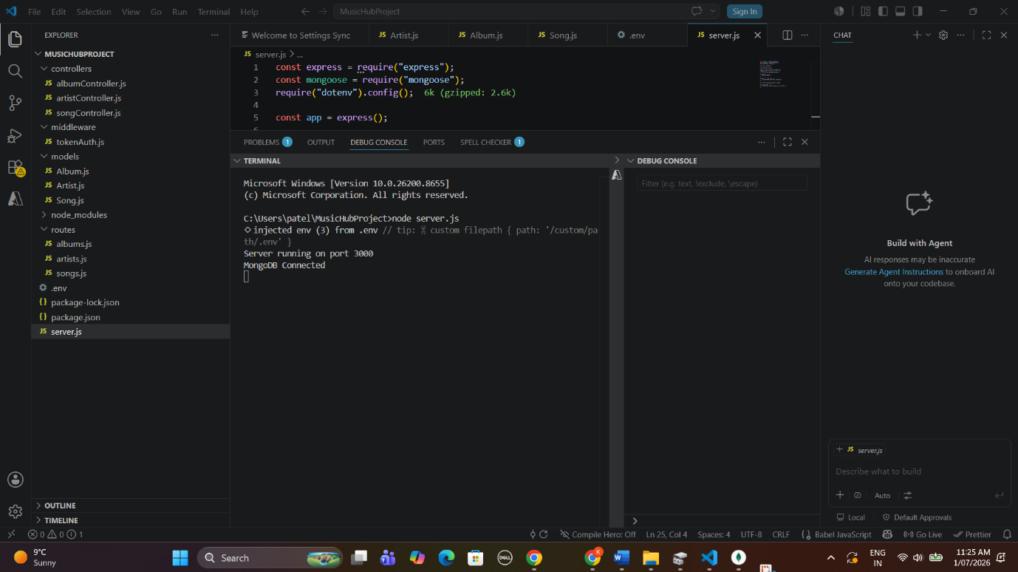
Database Collections
Three MongoDB collections were created.
- Artists
- Albums
- Songs
Each collection stores related information and references other collections using ObjectId.
I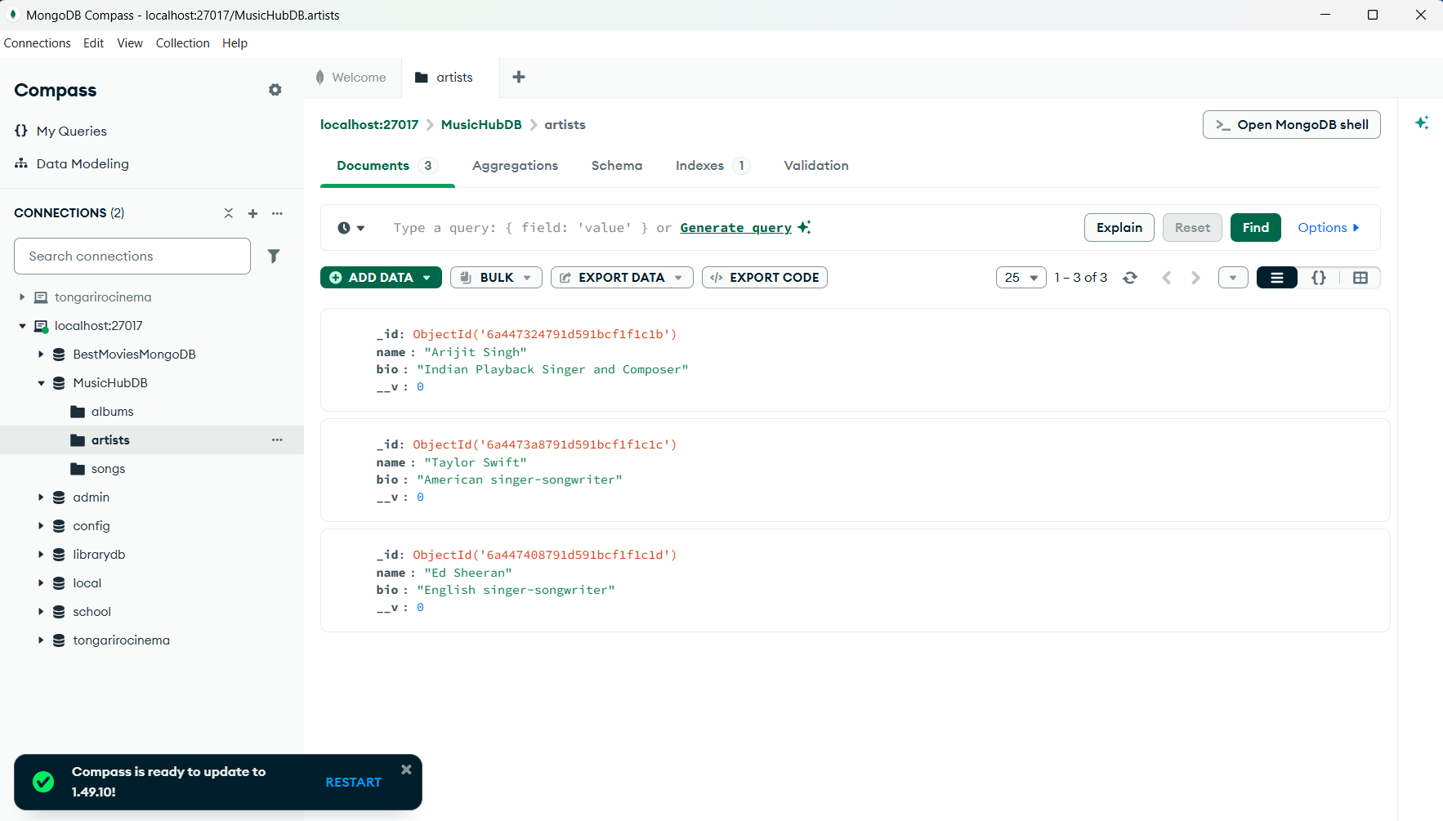
Models
Three Mongoose models were implemented.
Artist Model
Stores:
- Name
- Bio
Album Model
Stores:
- Title
- Release Year
- Artist Reference
Song Model
Stores:
- Title
- Genre
- Album Reference
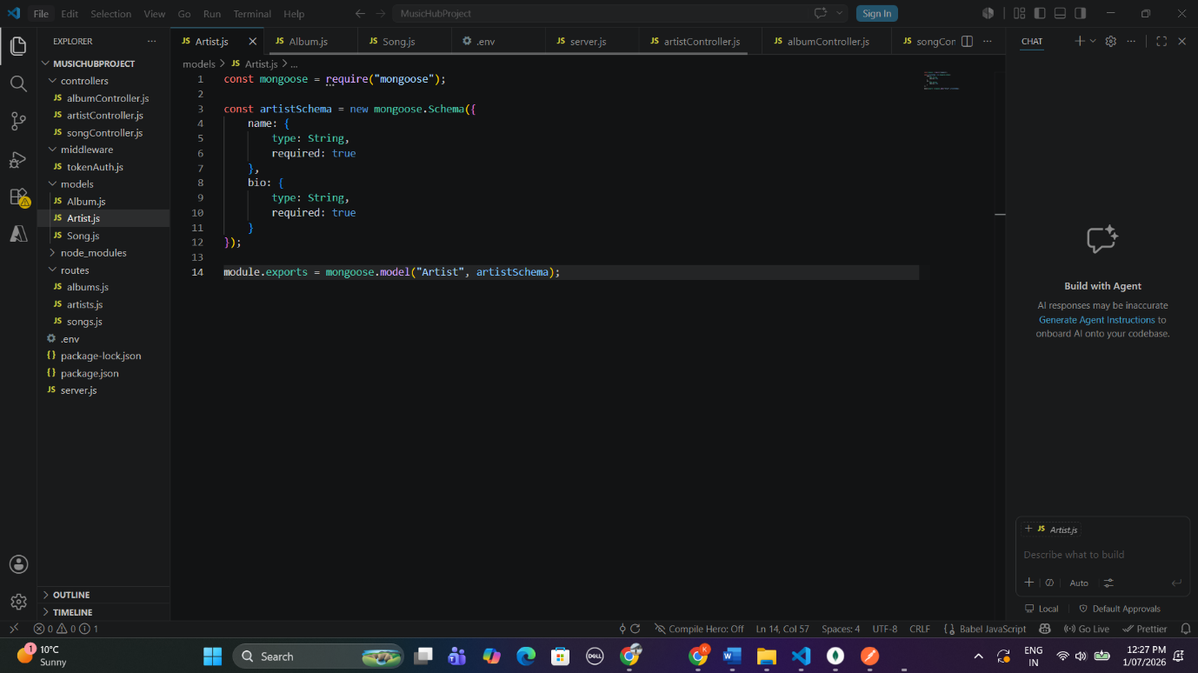
Controllers
Separate controllers were implemented for:
- Artist
- Album
- Song
Each controller contains CRUD operations including:
- GET
- GET by ID
- POST
- PUT

Routes
REST API routes were created for each collection.
Example routes:
GET /artists
GET /artists/:id
POST /artists
PUT /artists/:id
DELETE /artists/:id
The same structure was implemented for Albums and Songs.
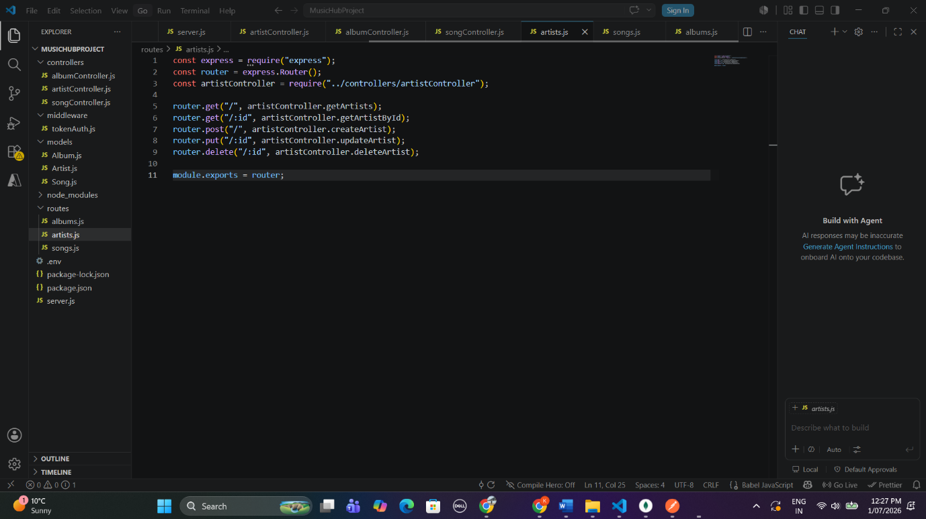
API Testing using Postman
All endpoints were tested successfully using Postman.

GET All Artists
Endpoint
GET /artists
The API returned all artists stored in MongoDB.
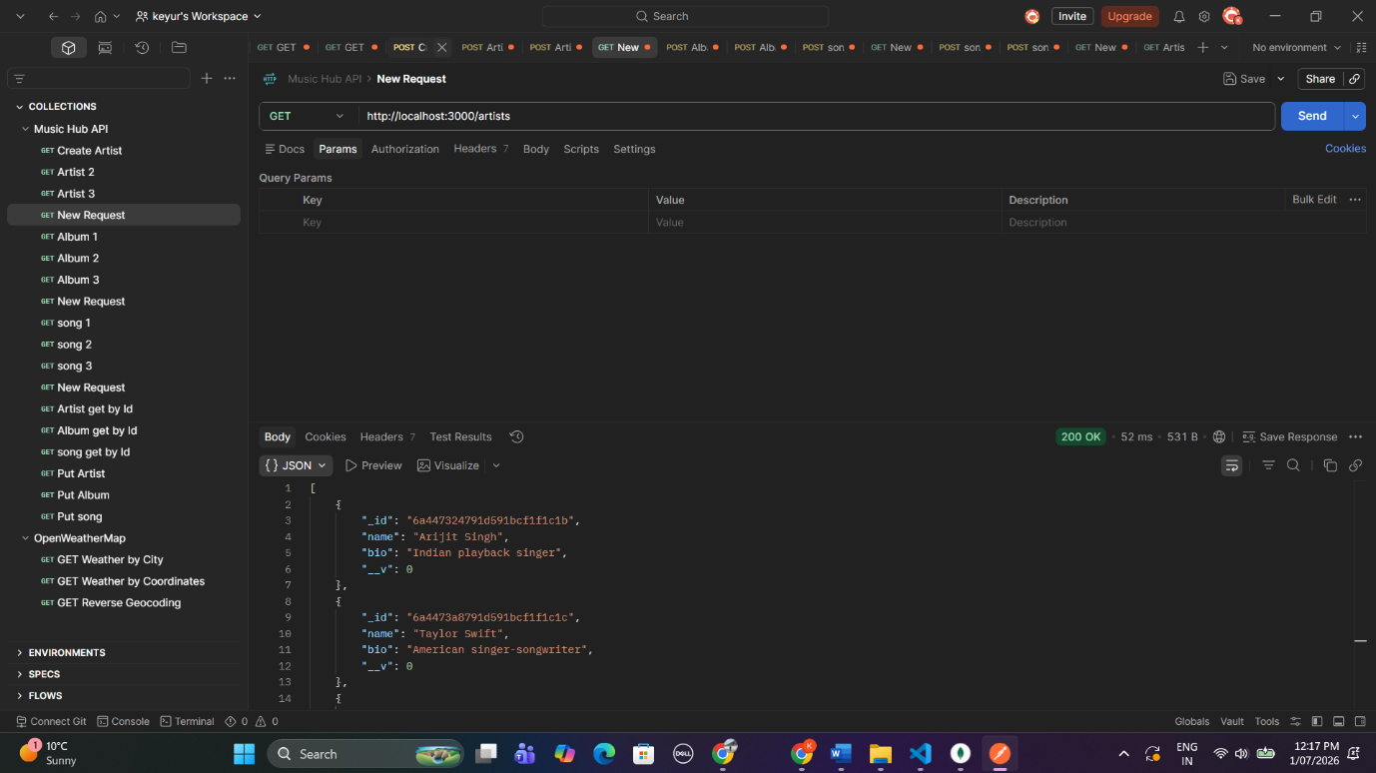
GET All Albums
Endpoint
GET /albums
Albums were returned with populated artist information.
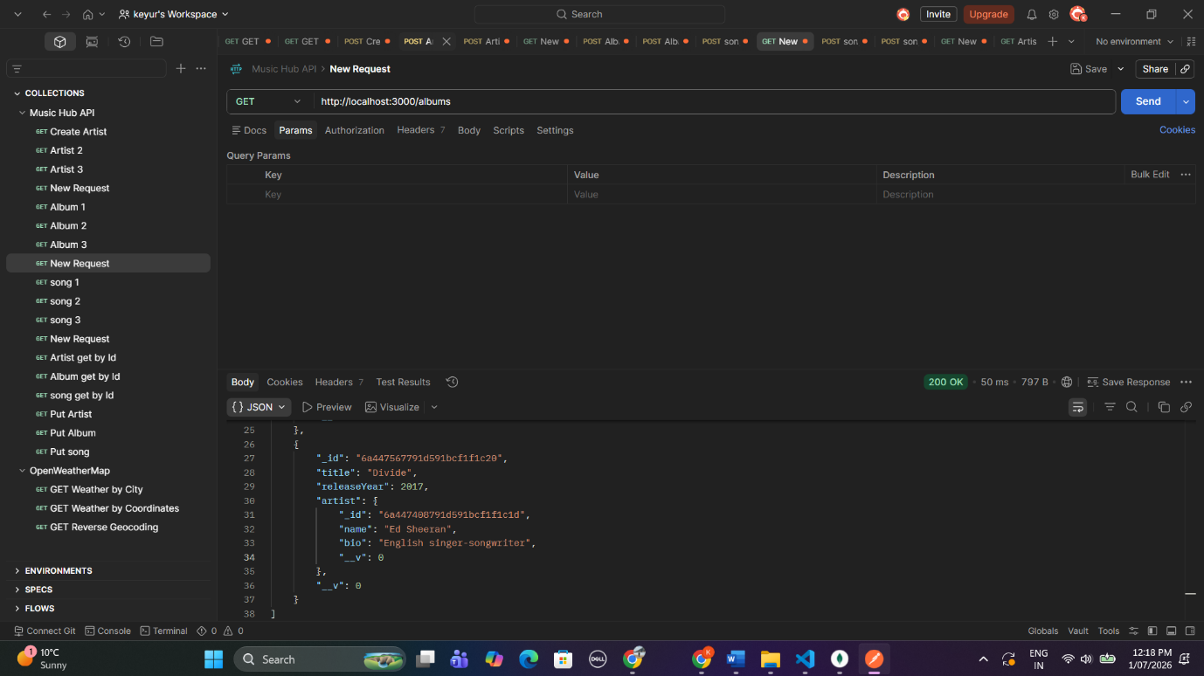
GET All Songs
Endpoint
GET /songs
Songs were returned together with album and artist details using Mongoose populate.
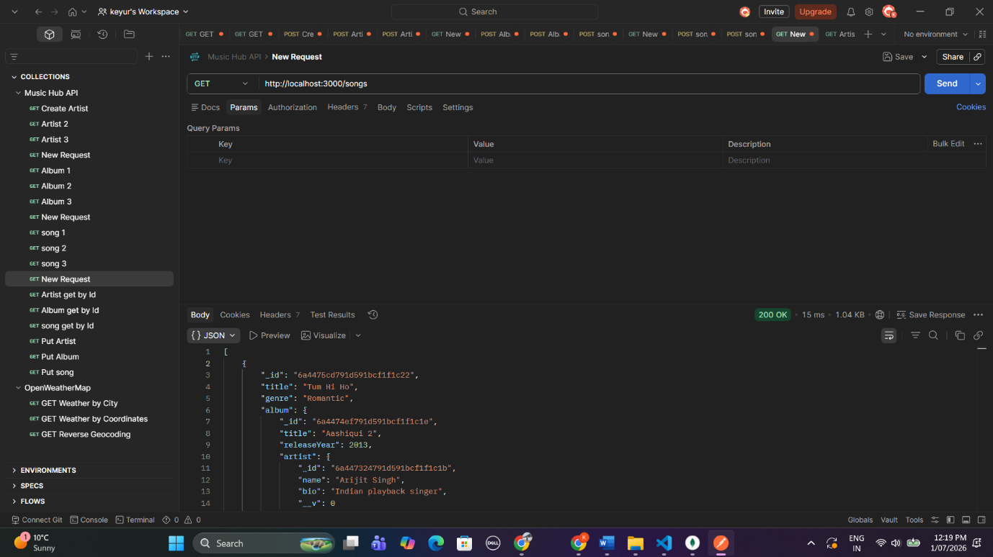
GET Artist by ID
Endpoint
GET /artists/:id
Successfully returned a single artist document.
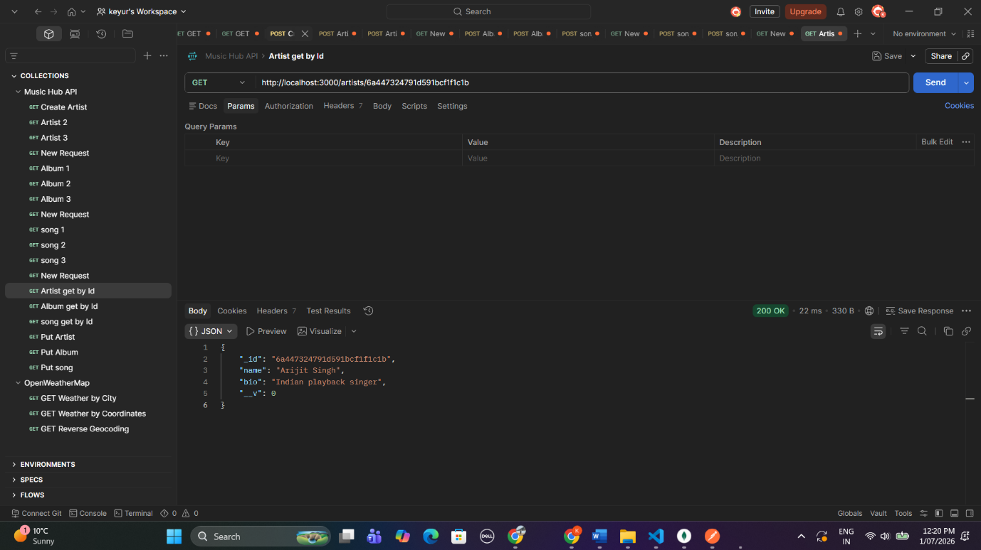
GET Album by ID
Endpoint
GET /albums/:id
Successfully returned the selected album.
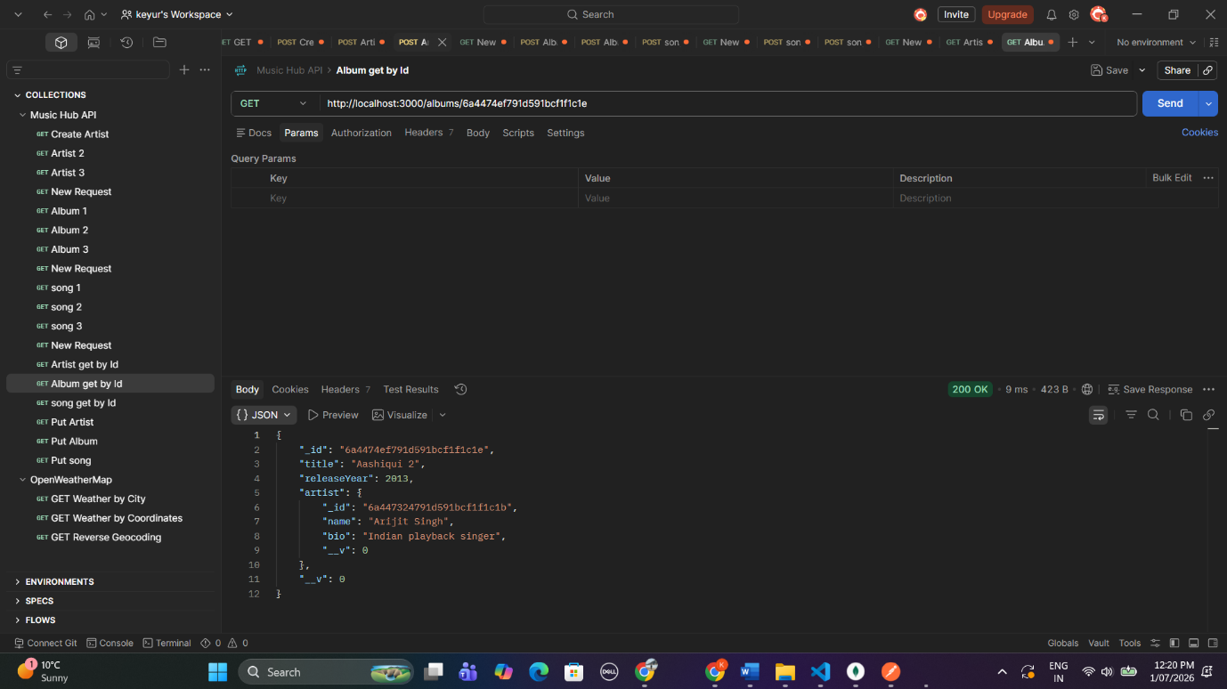
GET Song by ID
Endpoint
GET /songs/:id
Successfully returned the selected song together with album and artist information.
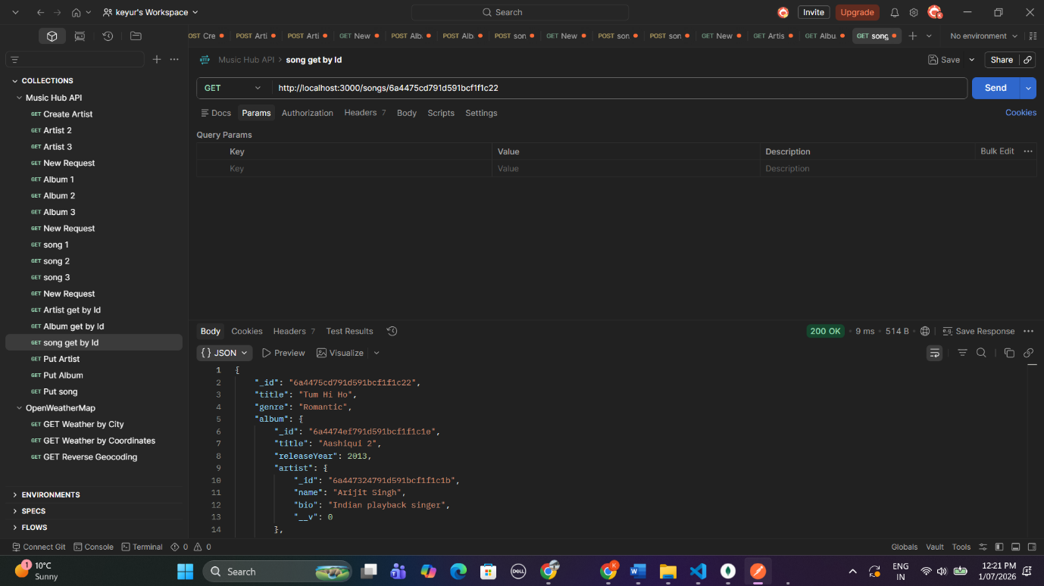
Update Artist
Endpoint
PUT /artists/:id
The artist biography was successfully updated.
Response:
200 OK
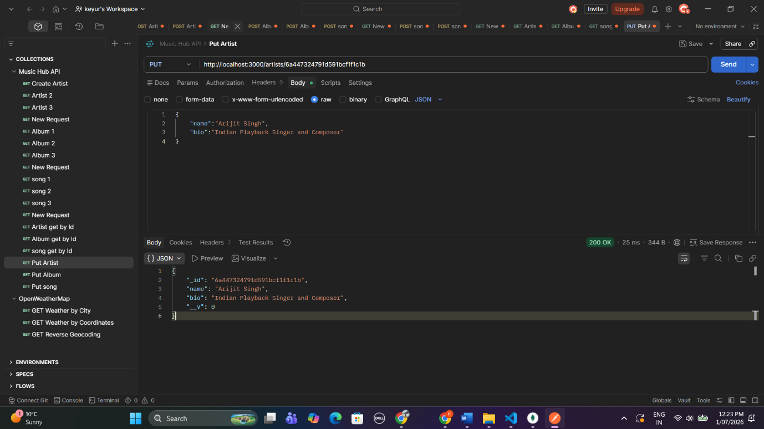
Delete Song
Endpoint
DELETE /songs/:id
The selected song was successfully removed from the database.
Response:
Song deleted successfully
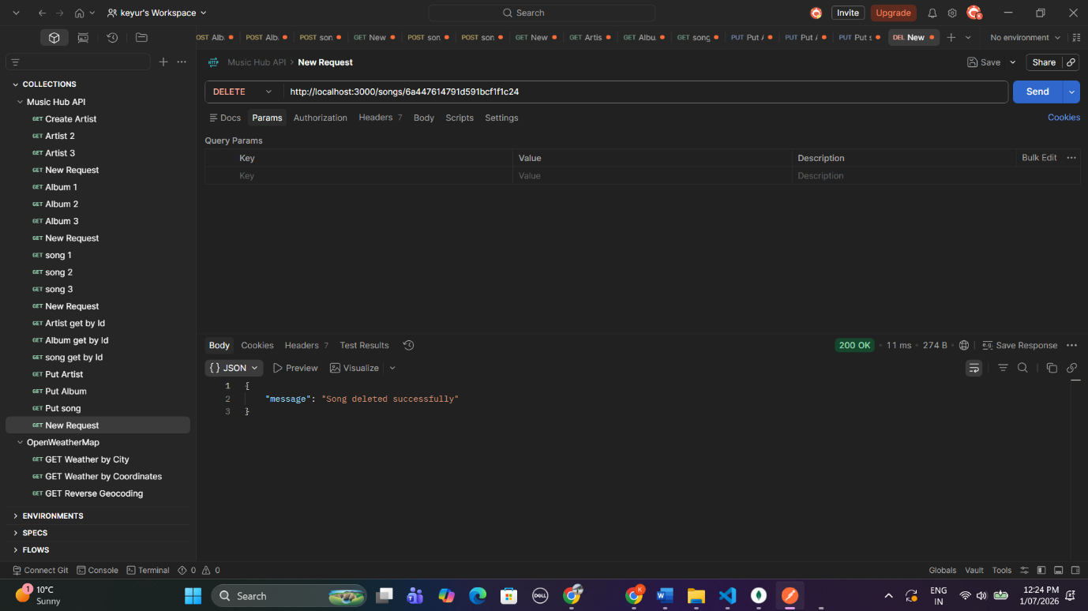
Conclusion
We managed to build a MUSICHUB REST API using the combination of Node.js, Express.js, MongoDB and Mongoose, the application we were tasked with building out and delivering at the end of the week! The app allowed for us to perform CRUD operations on the Artists, Albums, and Songs data. All of the application’s endpoints were fully tested in Postman, and were successfully persisted into our MongoDB database, as verified using MongoDB Compass. The assignment requirements have been successfully met!
Task 4 – JWT Authentication
4.1 User Data in MongoDB
Summary on JWT Authentication
REST API - Music Hub: REST API - Music Hub was protected with the help of JSON Web Token (JWT).passwords of user was encrpted using byrypt and then stored in mongodb database. When registered User login with a proper emailid andpassword server generate and send back JWT Token to theuser and that token was used in theAuthorization (Bearer Token)Header while making requests to securedendpoints.

I did Authentication testing using postman. After successfully logged in we get the JWT token. And using the token we can access the secured routes like accessing artist, album and songs. We also test it using invalid credentials and tried accessing the secured routes without token. The API responded with 401 Unauthorized. This shows the authentication was working well.
You can see a variety of tests, including a successful login, generating a token, authorized calls, failed logins, and testing of authorization.
4.1 User Data in MongoDB
Description:
User details are stored in the users MongoDB collection. In addition passwords are hashed and then encrypted before being saved. This improves security in the application.

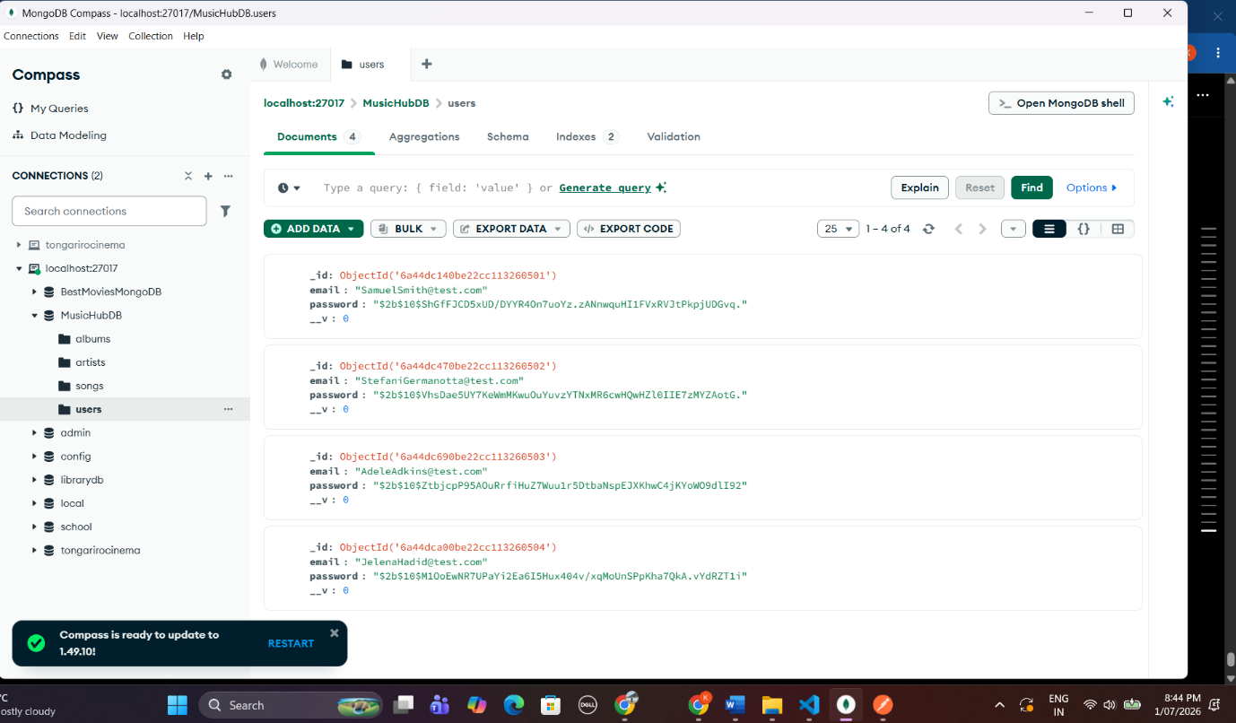
4.2 Successful Login
Description:
A username and password are submitted to the /api/users/login endpoint, which is checked for validity. The server responds by returning a JWT to authenticate protected routes.
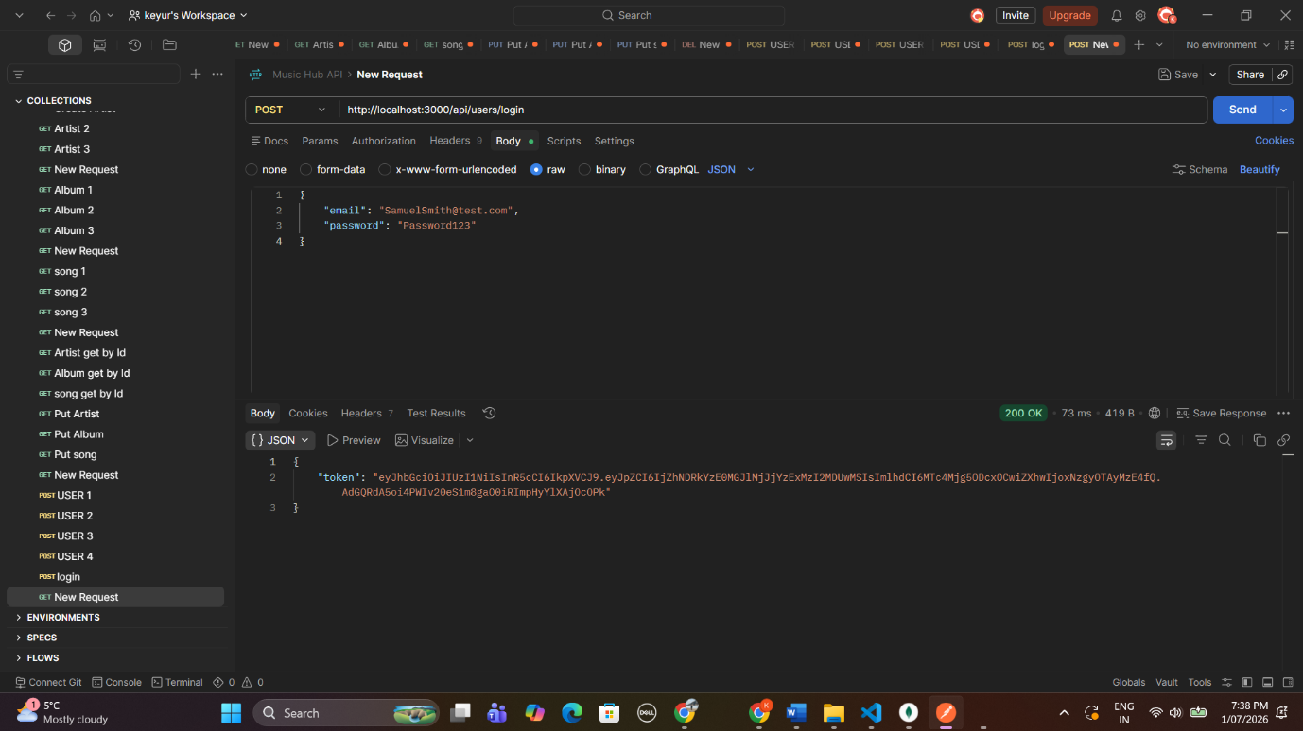
4.3 Failed Login
Description:
Password entry is incorrect. The API returns the password in response, with the status of 401 Unauthorized and a reply of “Invalid email or password”.
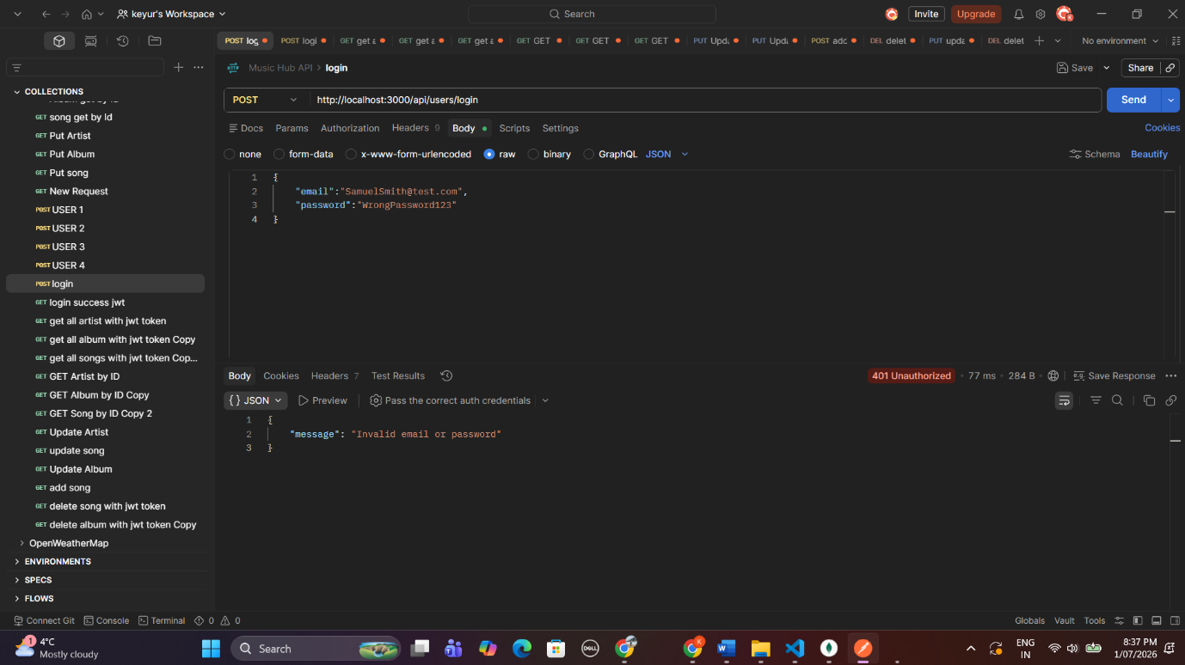
4.4 Accessing Protected Route Without Token
Description:
We are accessing a secured API endpoint without sending any JWT token in the request. The server responds to us with 401 Unauthorized, which is the expected behavior.

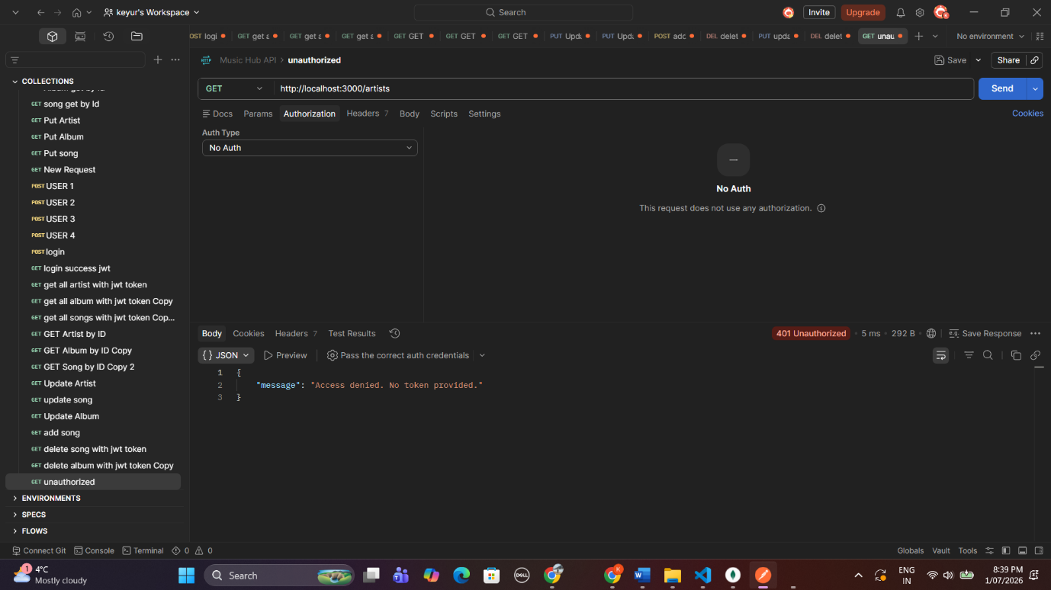
Task 5 – API Testing
I used Postman to test out the Music Hub API and used MongoDB Compass to verify. I was able to perform CRUD (Create, Read, Update, Delete) operations on all collections forArtists, Albums and Songs collections. I performed GET requests to retrieve all the documents and specific documents based on Object ID, I used POST requests to create documents in the collection, I used PUT to update records in the collection and used DELETE to delete records from the database along with appropriate success responses.
I was able to verify data being written into users, artists, albums and song collections using MongoDB Compass.
I also validated the association of albums to artists and songs using references populated by the API. The screenshot below showcase performing CRUD operations, using JWS token with protected API routes, and validating data into MongoDB database and ensuring the overall system working as expected meeting all project requirements.

GET All Artists
Purpose:
Get all artist records from DB

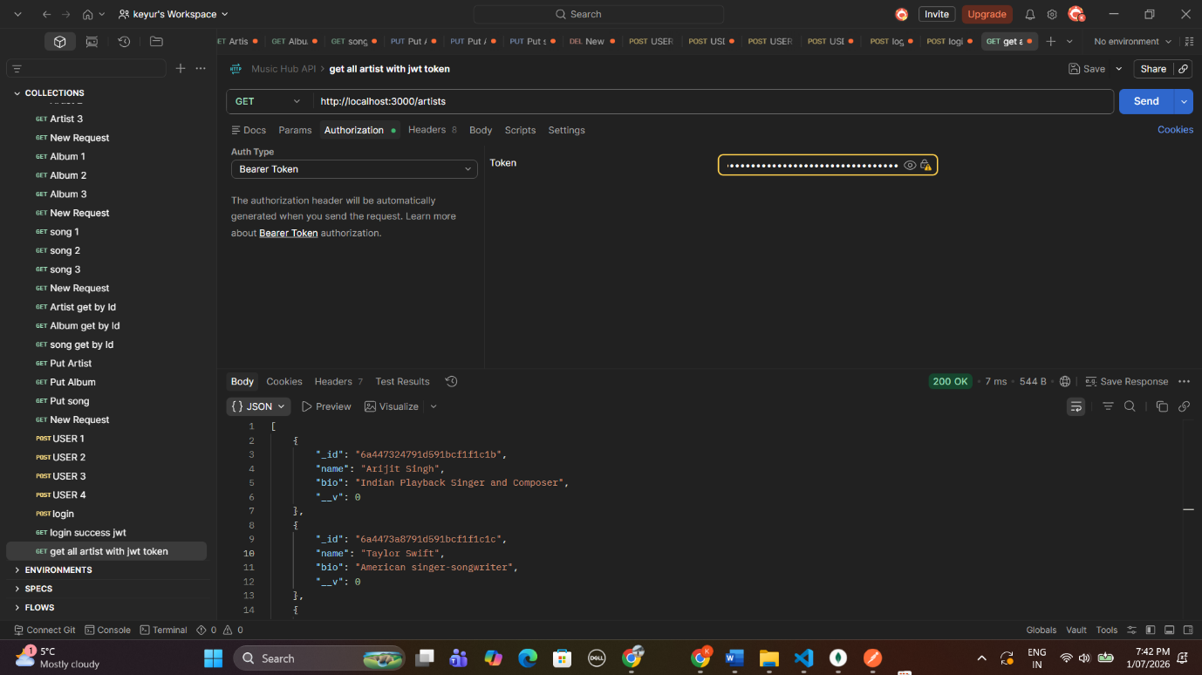
GET All Albums
Purpose:
Get me album information.

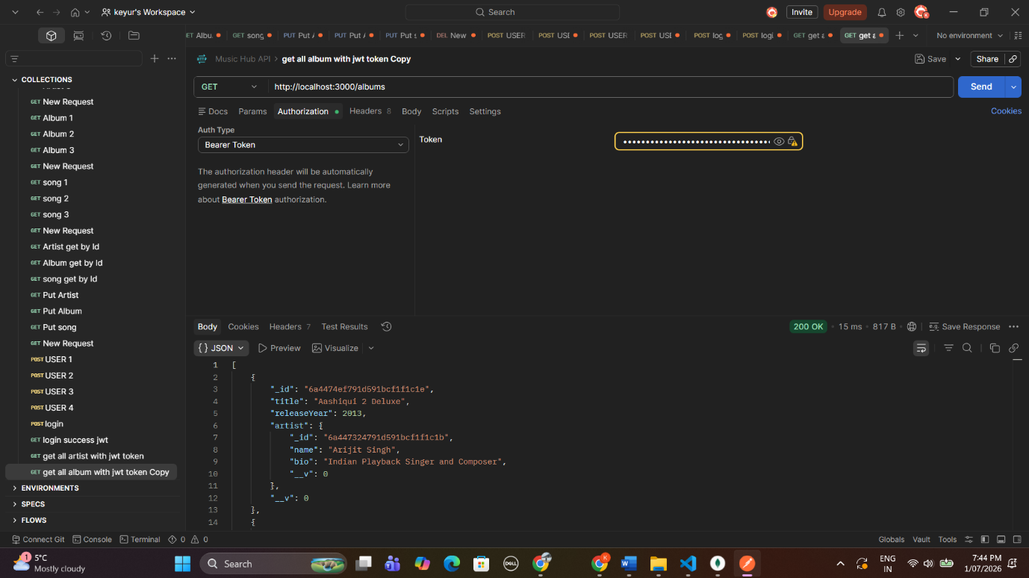
GET All Songs
Purpose:
Get all songs with album/artist populated.

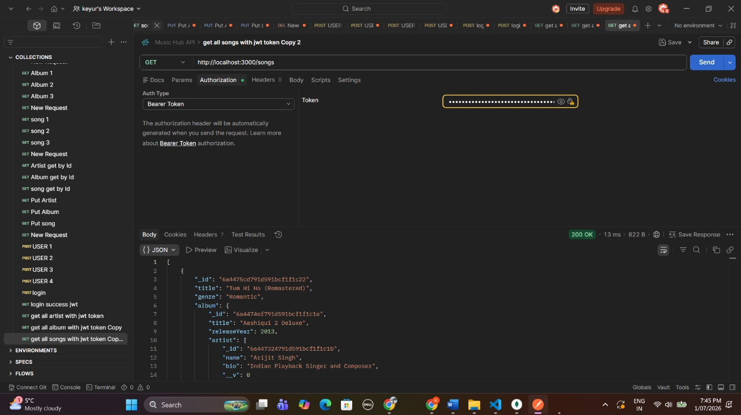
GET Artist by ID
Purpose:
Fetch an artist via their unique MongoDB ObjectId

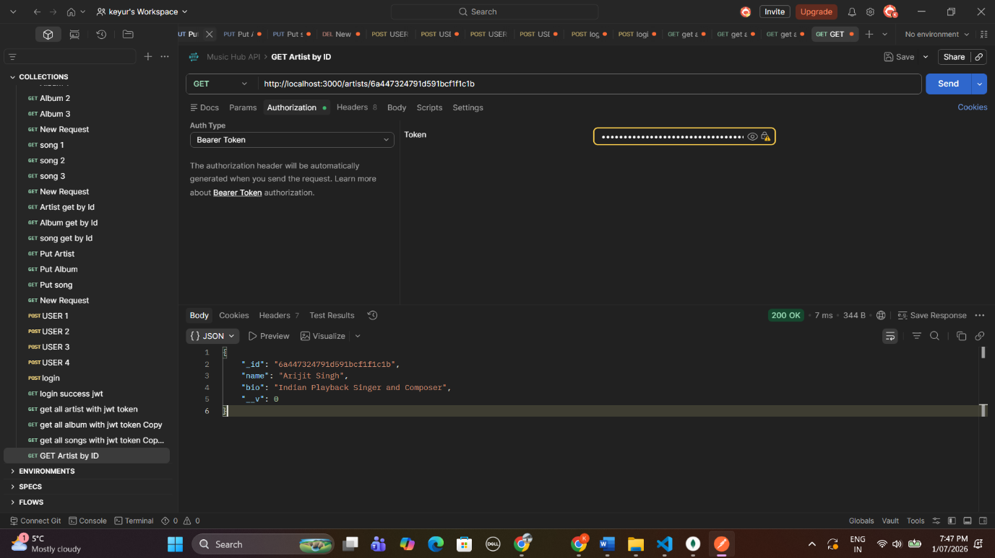
GET Album by ID
Purpose:
Return album object by ObjectId.

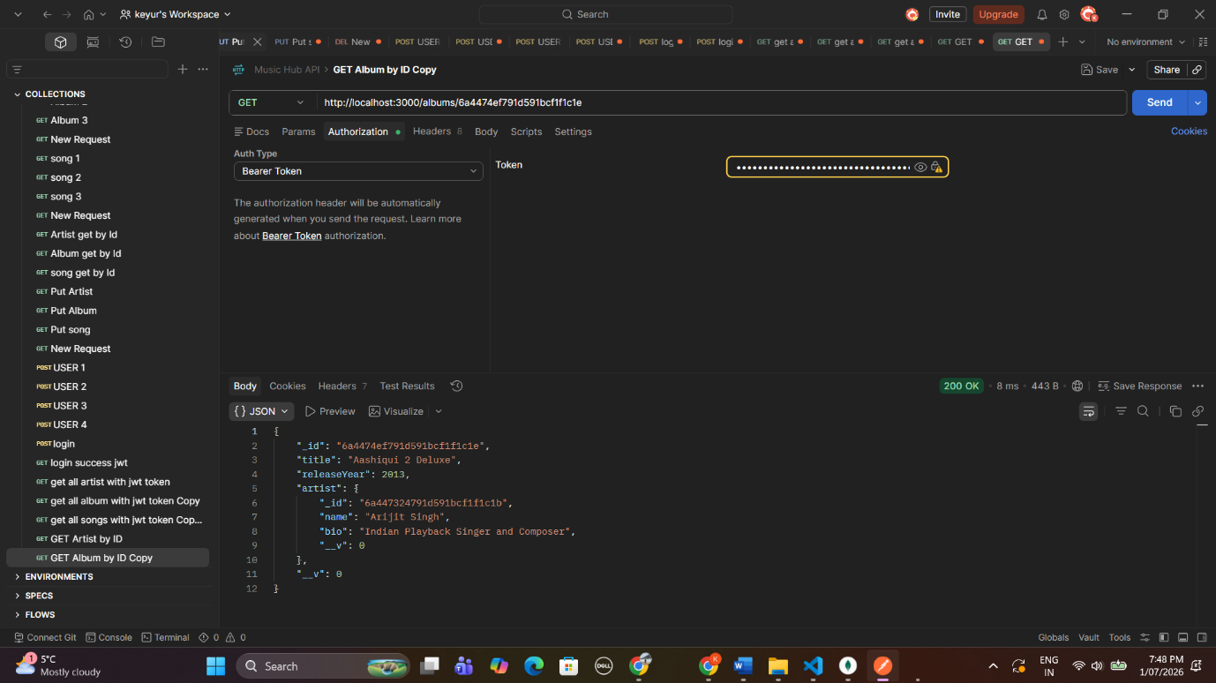
GET Song by ID
Purpose:
songRetrieveSong.objectId

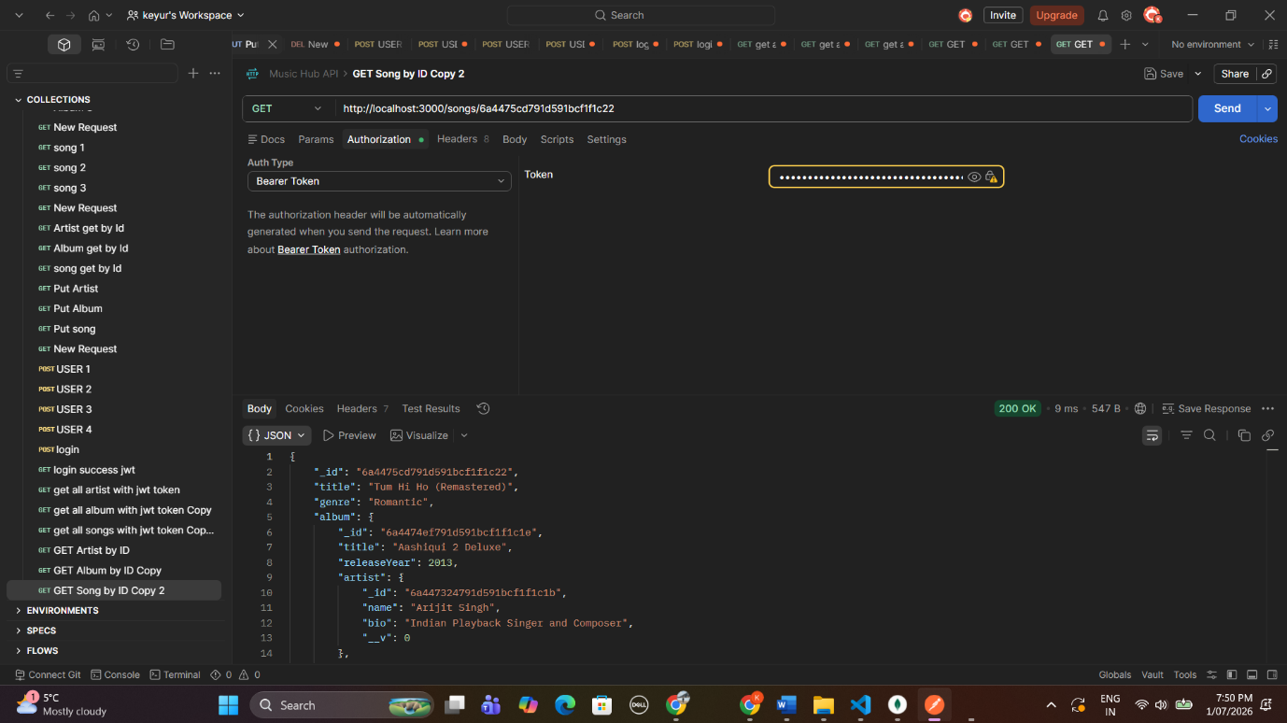
Update Artist
Purpose:
Update an existing artist record using the PUT method.
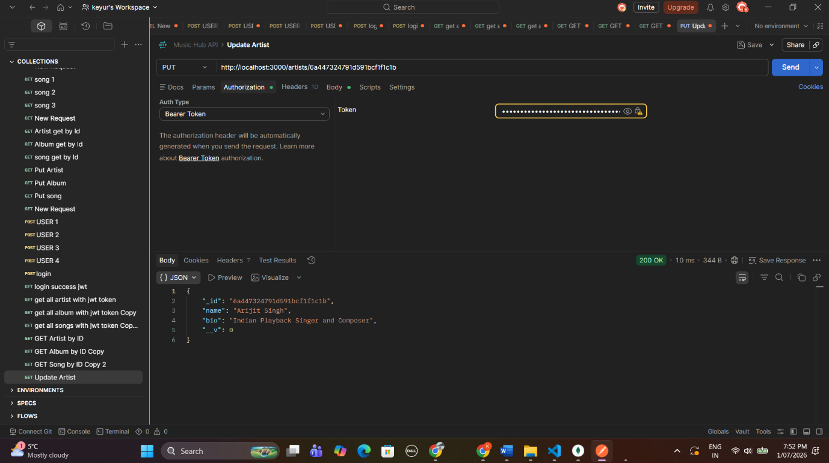
Update Album
Purpose:
Update an existing album record using the PUT method.
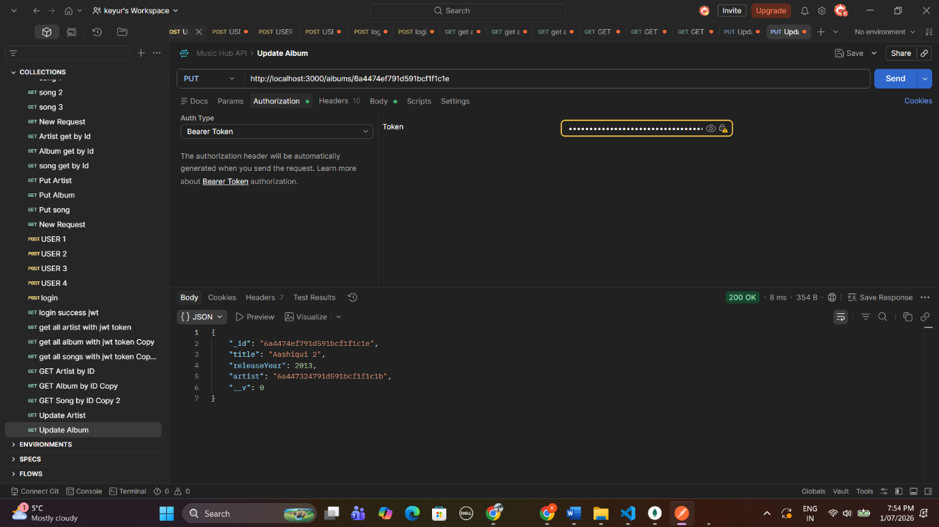
Delete Song
Purpose:
Delete an existing song using the DELETE method.
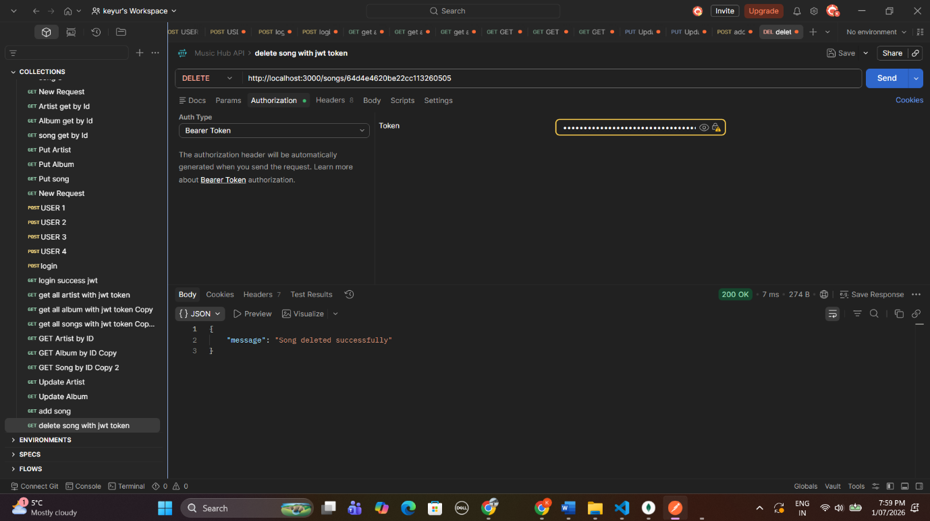
Delete Album
Purpose:
Delete an existing album using the DELETE method.
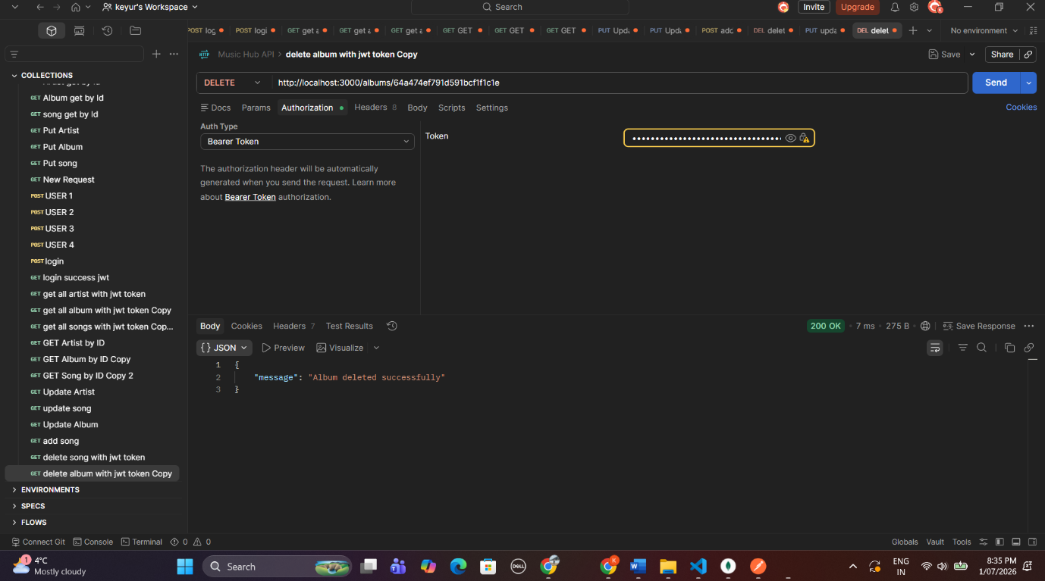
Conclusion
Every endpoint in the API was tested on Postman, CRUD on artists, albums, and songs all worked and responded as expected and they were reflected correctly in MongoDB Compass after each query. The outcome proves the Music Hub REST API has been successfully completed.

